**WEB APPLICATION USING DYNAMIC CONCEALMENT IN RECITAL VISUAL BLOCKCHAIN**

**A PROJECT REPORT**

*Submitted by*

**S.GOPINATH**

**(18-PCA-025)**

*In partial fulfilment for the award of the degree of*

MASTER OF COMPUTER APPLICATIONS (MCA)

Under the guidance of

**PROF. VIJAYA PETERRAJ**

M.C.A, M.PHIL



**LOYOLA COLLEGE (AUTONOMOUS)**

**CHENNAI-600034**

**APRIL - 2021**

**BONAFIDE CERTIFICATE**

This is to certify that the project work titled ‘**Dynamic concealment in recital visual blockchain**’ is being submitted to the Department of Computer Applications (MCA), Loyola College (Autonomous), Chennai-34 by **S.GOPINATH (18-PCA-025**) for the partial fulfilment for the award of degree of MASTER OF COMPUTER APPLICATIONS is a Bonafide record of work carried out by him, under my guidance and supervision.

Head of the Department Project Guide

Dr. C. Muthu Prof. VIJAYA PETERRAJ

M. Sc., M. Tech., Ph. D M.C.A , M.PHIL

Submitted for the Viva-Voce Examination held on

Internal Examiner External Examiner

**COMPLETION CERTIFICATE**

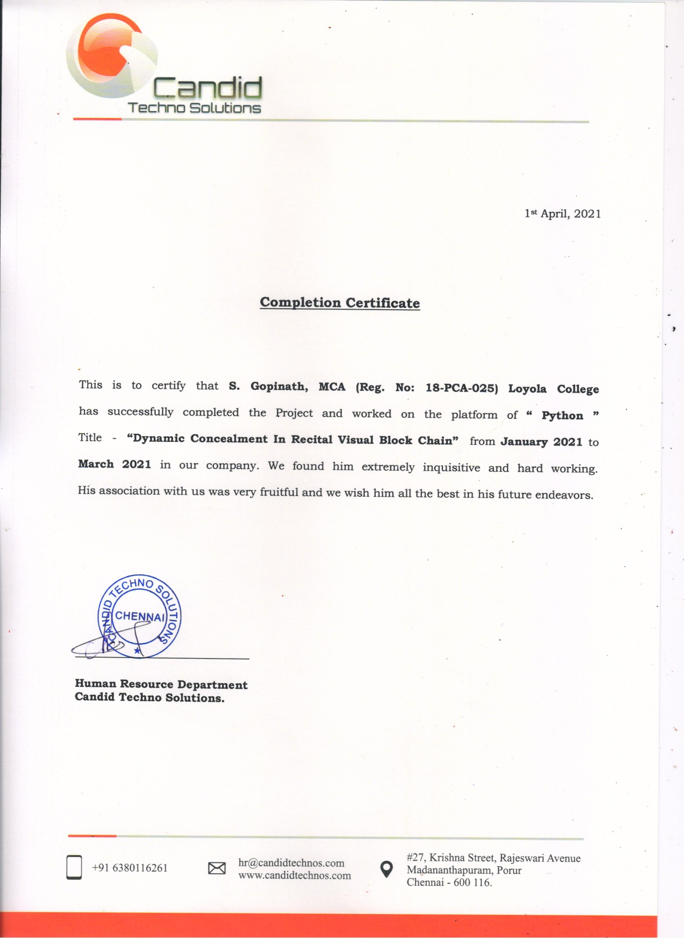

**Department of Computer Applications(MCA)**

**Loyola College, Chennai – 34**

**INDIVIDUAL CANDIDATE PROJECT Evaluation form FOR THE YEAR 2020 – 2021**

|  |  |  |  |  |  |  |  |  |  |
| --- | --- | --- | --- | --- | --- | --- | --- | --- | --- |
| Candidate Dept Number | 1 | 8 | P | C | A | 2 | 5 | Candidate Name | S.GOPINATH |

|  |
| --- |
| Please use the space on the reverse for any comments about the project(s), making, and help given to the candidate beyond normal supervision. Comments are especially important where the marks awarded differ from what might have been expected on the sole evidence of the submitted material. |
| Title(s) of Project(s) :  **Dynamic concealment in recital visual blockchain**  Name and Address of the Company :CANDID TECHNO SOLUTION , PORUR CHENNAI -600116 |
| |  |  |  |  |  |  |  |  |  |  |  |  |  |  |  |  |  |  |  |  |  |  |  | | --- | --- | --- | --- | --- | --- | --- | --- | --- | --- | --- | --- | --- | --- | --- | --- | --- | --- | --- | --- | --- | --- | --- | |  | | The Problem | | | | | | Design | | | | Implementation | | Testing | | Documentation | | Evaluation | |  |  |  | |  | | Description of the Problem | Specific Objectives | Description of existing solution | Evaluation of existing solution | Description of other possible solutions | Evaluation of other possible solutions | Overall plan | Description of method of solution | Hardware requirements | Software requirements | Method of solution related to problem | Accurate method of solution | Test strategy | Test results | Technical documentation | User documentation | Evaluation | System development | Technical skill | TOTAL | FINAL TOTAL | | Section | | 1 | 2 | 3 | 4 | 5 | 6 | 7 | 8 | 9 | 10 | 11 | 12 | 13 | 14 | 15 | 16 | 17 | 18 | 19 |  |  | | Max | | 4 | 6 | 4 | 4 | 4 | 4 | 6 | 6 | 6 | 8 | 4 | 4 | 6 | 8 | 4 | 6 | 6 | 4 | 6 | 100 | 50 | |  |  |  |  |  |  |  |  |  |  |  |  |  |  |  |  |  |  |  |  |  |  |  |   Name and Address of the Company : |

26 26 8 14 10 10 6 100

|  |  |  |  |  |  |
| --- | --- | --- | --- | --- | --- |
| Name of teacher completing this form |  | Signature |  | Date |  |
| Name of Guide |  | Signature |  | Date |  |

HOD Project Coordinator Date

**ACKNOWLEDGEMENT**

First of all I thank the almighty God for His blessings and grace by which I was able to complete this project successfully.

I extremely thank Rev. Dr. A.Thomas S.J, Principal, Loyola College for giving me a chance to pursue in this great institution.

I extend my heartfelt thanks to Dr. C. Muthu, The Head of the Department, Loyola College, for his constant encouragement.

I would like to thank Prof. Vijaya Peterraj, my project guide for giving good guidance and a good environment for developing and completing my project.

I do really owe a token of gratitude to all the members of the Department of Computer Applications (MCA) both teaching and non-teaching staff for their direct and indirect assistance for the successful completion of the project.

**Abstract**

Banking and technology are very closely associated and innovations have changed banking drastically over the period of time. The digital innovations in the banking sector started with the introduction of money that replaced the barter system and then the gradual replacement of wax seal with digital signatures. One such disruptive innovation which is changing the banking sector globally is Blockchain Technology (BCT). Blockchain is shared distributed ledger which stores business transaction to a permanent unbreakable chain which can be viewed by the parties in a transaction. Blockchain technology has the potential to disrupt the financial business applications as it provides permanent and tamper proof recording of transactions in a distributed network. It can be widely applied in digital currency, trade finance, and KYC etc. Although the potential of blockchain is enormous, it has various limitations of security, privacy and scalability which need to be addressed. Aim of project is to provide the overview of blockchain technology with its benefits and emphasizing on the applications of the technology in the Indian Banking Sector. Document gives insight of various challenges and global perspective of blockchain technology in Banking Industry. The utility of Blockchain is that financial transactions no longer require any central authority and are immediately validated, cleared and settled. Blockchain technology appears to be an innovation which promises a major change for capital markets and other financial services.

**INDEX**

|  |  |  |
| --- | --- | --- |
| **CHAPTER** | **TABLE OF CONTENTS** | **PAGE NO** |
|  | List of Tables  List of Figures  List of Abbreviations | i  ii  iii |
| 1 | **The Problem**  1.0 Introduction  1.1 Description of the problem  1.2 Objectives  1.3 Description of Existing System  1.4 Evaluation of Existing System  1.5 Description of Proposed System  1.6 Evaluation of Proposed System  1.7 Conclusion | 1  1  4  5  7  9  10  11 |
| 2 | **Design**  2.0 Introduction  2.1 Project Plan  2.2 Description of the method of solution  2.3 Pseudo Code  2.4 System Description  2.4 Software requirements  2.5 Hardware requirements  2.6 Conclusion | 12  12  13  21  22  24  24  29 |
| 3 | **Implementation**  3.0 Introduction  3.1 Method of solution developed related to problem  3.2 Accurate method of solution  3.3 Conclusion | 30  30  30  36 |
| 4 | **Testing and Documentation**  4.0 Introduction  4.1 Test strategies  4.2 Test Results  4.3 Technical documentation  4.4 User documentation  4.5 Conclusion | 37  37  38  43  50  51 |
| 5 | **Conclusion**  5.0 Introduction  5.1 Evaluation  5.2 Future Enhancement  5.3 Technical skills learned  5.4 Conclusion | 52  52  53  54  55 |
| 6 | **Bibliography**  **Appendix**  Screenshots  Attendance Sheet  Document Sheet  Weekly Reports & Monthly Reports | 56  57  57 |

**LIST OF TABLES**

|  |  |  |
| --- | --- | --- |
| **Table No** | **TABLE NAME** | **PAGE NO** |
| 2.1 | Overall Plan of the Project | 12 |
| 2.2 | Login Registration | 19 |
| 2.3 | Login Page | 20 |
| 2.4 | Help Desk | 20 |
| 2.5 | Hardware Requirement | 24 |
| 2.6 | Software Requirement | 25 |
| 4.1 | Test Result Of Unit Testing | 39 |
| 4.2 | Test Result Of Integration Testing | 42 |
| 4.3 | Test Result Of Database Testing | 43 |
| 6.1 | Evaluation of Checklist | 53 |

**LIST OF FIGURES**

|  |  |  |
| --- | --- | --- |
| **Figure No** | **Figure Name** | **Page Number** |
| 1.1 | Organization Chart | 4 |
| 2.1 | DFD 0 | 14 |
| 2.2 | DFD 1 | 14 |
| 2.3 | DFD 2 | 15 |
| 2.4 | DFD 03 | 15 |
| 2.5 | Home Page | 16 |
| 2.6 | Transaction Page | 17 |
| 2.7 | Account Page | 17 |
| 2.8 | Menu Page | 18 |
| 2.9 | Admin Page | 19 |
| 4.1 | Outline Interation 1 | 39 |
| 4.2 | Outline Interation 2 | 41 |
| 4.3 | Outline Interation 3 | 42 |
| 4.4 | Pycharm Website | 44 |
| 4.5 | Select operation bit | 44 |
| 4.6 | Setup Wizard | 45 |
| 4.7 | Path location | 45 |
| 4.8 | Install button | 46 |
| 4.9 | Pycharm community | 46 |
| 4.10 | Ready too code | 47 |
| 4.11 | Select Language | 47 |
| 4.12 | Licence Terms | 48 |
| 4.13 | Installation Package | 48 |
| 4.14 | Location for Download | 49 |
| 4.15 | Sql Package | 40 |
| 4.16 | Passcode for access | 50 |

**CHAPTER 1**

**THE PROBLEMS**

**1.0 Introduction**

In this chapter the existing system is explained in detail along with the proposed solution. A detailed study has been done on the existing system and by referring lots of web resources, the idea of using the proposed technology and language were selected based on the problems to be overcome and the features of the web application.

**1.1 Description of the problem**

The banking sector stands to gain a lot by replacing their outdated systems for settling transactions with the newest offerings from the likes of Ripple and its competitors. Ripple is designed to be a high throughput blockchain which could handle upwards of 1500 transactions per second. Ripple achieves this by sharing the authentication privileges with a limited number of trusted nodes that can be run by banks themselves or public institutions such as universities. This gives banks with official records of asset ownership as the authenticators are legally responsible for processing transactions honestly. Switching over to Ripple’s xRapid service could help expedite their transaction settlements many times over while at the same time reducing their costs by over 40%. Ripple’s two main offering for bank-to-bank transfers are xCurrent and xRapid. xCurrent similar to the SWIFT messaging system and allows for settlement in cross-border payments but still requires traditional banking accounts to be held by participating banks. The real benefits of blockchains can, however, be seen in the xRapid system which utilizes Ripple’s native XRP token. xRapid significantly improves speed and reduces costs for cross-border payments by using XRP as a bridge asset between currencies thus eliminating the need for traditional banking accounts. But the problem with Ripple Blackchain is that Ripple seems to have legal problems as the company deals with several Database concerning various issues including registration violation and data loss. The most long-standing problem is the matter concerning the nature of XRP Server which created the XRP token.

**About the Organization**

The main focus of the Candid Techno Solution company is on developing a business model that has a clear idea on providing a cost-effective software and application to all of the clients’ around the world. They believe in using the creativity and strong potential in providing website and other application solutions with including of easy to access and more compatible. It’s a fun to work in a company where employees truly believe in what actually they are doing. The company have a strong work-life balanced environment and trust the employees to do their job effectively. The company need to add innovate and bright people to the teams to help us continue to succeed and grow.The regularly work with all kind of businesses and the great industry knowledge to deal with all kinds of clients in the industry market.



**The Process**

* Analyze
* Develop
* Execute
* Evaluate

**The Quality Assurance**

* Service
* Efficiency
* Reliability
* Standard
* The Vision

Our focused commitment to strong approach and process, we aim to go beyond the clients’ expectations.

**The Mission**

We Develop application and software to face the real-world business challenges, that will provide continues support to all of our clients.

**Services**

* Application development
* Infrastructure Management
* Web designing
* Mobility Solution
* Cloud Computing
* product Engineering services
* Big Data
* Business Intelligence

**Organization Chart**

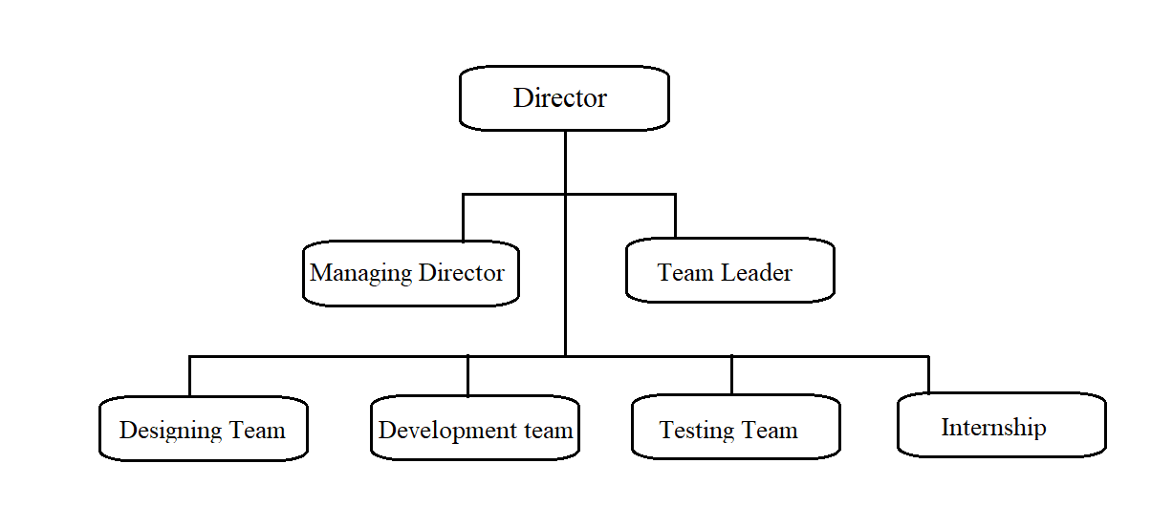

*Figure 1.1 Organization Chart*

**Student Project Assignment and Responsibility**

As an Intern, my role in the organization is to understand the actual problem and help the developers in designing, coding and testing. The project which is assigned to me is Web Application for Dynamic concealment in recital visual block chain.

**1.2 Objective:**

The applications provide the most faster and quick access of the banking process to deliver more value to the customers. It includes security, Validation, less processing time, tracking, This application integrates with the interactive help support from support team.

**The following services were used to develop the Web Application:**

* Customers will register with the User Id and Password.
* To know the status of the Account.
* Remind the customers about the information through the notification
* Know the details of the previous transaction.
* Update the upcoming schedule.
* Provides high authentication and data security.

**1.3 Description of Existing System**

The below details illustrates about the existing problem solution of the project.

**1.3.1 Mobile Banking**

A banking app is a mobile app where you can access the details of your bank account and complete transactions directly from your phone, tablet, or mobile device. Based on the bank you’re accessing, you’ll be able to complete a variety of actions via your banking app. mobile banking apps can warn you when you spend more than you have in your account, automatically move money into savings on your payday and let you set controls on your cards to restrict spending.

The apps can also send you account alerts, let you tap a button in a bank app to call a customer service representative and pay back a friend.Using a mobile banking app increases ease of use, speed, flexibility and also improves security because it integrates with the user built-in mobile device security mechanisms. From the bank's point of view, mobile banking reduces the cost of handling transactions by reducing the need for customers to visit a bank branch for non-cash withdrawal and deposit transactions.

Some banks offer different mobile apps for different banking services. For instance, the bank may offer an e-Passbook app that only serves the purpose of account balance check since the app acts like a digital passbook and there is another mobile app for other services such as funds transfer, bill payment, and more in addition to balance check.

**1.3.2 Reply Blockchain App**

Blockchain offers an innovative approach to storing information, executing transactions, performing functions, and establishing trust in an open environment. Many consider blockchain as a technology breakthrough for cryptography and cyber security, with use cases ranging from globally deployed crypto currency systems like. This paper presents a comprehensive overview of the security and privacy of blockchain. To facilitate the discussion, we first introduce the notion of blockchains and its utility in the context of Bitcoin like online transactions.

Then we describe the basic security properties that are supported as the essential requirements and building blocks for Bitcoin like crypto currency systems, followed by presenting the additional security and privacy properties that are desired in many blockchain applications.

Finally, we review the security and privacy techniques for achieving these security properties in blockchain-based systems, including representative consensus algorithms, hash chained storage, mixing protocols, anonymous signatures, non-interactive zero-knowledge proof, and so forth. We conjecture that this survey can help readers to gain an in-depth understanding of the security and privacy of blockchain with respect to concept, attributes, techniques and systems.

**1.3.3 Bank balance enquiry**

All Bank Balance Enquiry app will help you to give a miss call to the official number of your bank and in turn the bank will reply via SMS with your account balance. Through this app you can avoid the use of internet banking and frequent visit to ATM counter to check your balance.

The most astounding feature of this app is that you do not need internet to use this app and the number listed in this app is toll free that means All Bank ATM Balance Checker is completely free by all means. This app covers most of the Indian banks.With this app you can also solve your query related to your bank account by just giving a call on a Customer care number. Bank balance check app provides most of the banks Official missed call numbers. Bank Balance Inquiry enables you to view your bank account balance, mini statement & customer care number with just a single tap.

All Bank Balance Enquiry app provides following details. IFSC Code: Get IFSC code for all banks of INDIA. Balance Enquiry: You can get all banks balance enquiry at one place and free of cost, Just choose you bank click on call (its free of cost miss call service for most of banks) you will get an sms from bank on your registered mobile number.

**1.4 Evaluation of Existing System**

The below details illustrates about the evaluation of existing system

**1.4.1 Mobile Banking**

Mobile banking apps can warn you when you spend more than you have in your account, automatically move money into savings on your payday and let you set controls on your cards to restrict spending. The apps can also send you account alerts, let you tap a button in a bank app to call a customer service representative and pay back a friend.

**Advantages**

* Accessing the bank 24/7
* Optimizing your money
* Paying IOUs
* Strengthening security
* Providing added controls
* Offering clarity of where your financial data is going
* Giving you tailored options

**Disadvantages**

* frustrated with a digital banking
* Navigating the apps can feel daunting
* Cash gets lock at some time
* Not all mobile banking apps work well

**1.4.2 ReplyBockchain**

The app allowed users to insert pre-defined replies called "Smart Replies" into conversations on messaging apps on their phone such as Facebook Messenger, Slack and Google Hangouts.

**Advantages**

* Provide High Security
* Low Fragmentation And Easy Testing
* Allow To Penetrate Developed Countries Markets
* Secure Transactions

**Disadvantages:**

* Use excessive energy
* Implementation of cyber security is difficult
* Huge distributed computing system
* Mining does not provide network security
* Entries do not last forever or are not immutable

**1.4.3Bank balance enquiry**

All Bank Balance Enquiry app will help you to give a miss call to the official number of your bank and in turn the bank will reply via SMS with your account balance. Through this app you can avoid the use of internet banking and frequent visit to ATM counter to check your balance.

**Advantages:**

* Ease of Banking
* Available 24*7
* Multipurpose

**Disadvantages:**

* Chances of Fraud
* Non Availability of Internet
* No Personal Touch

**1.5 Description of Other possible Solution**

The below details illustrates about the description of proposed system.

**1.5.1 Secure Banking**

The possible solution is to develop Blockchain technology is a new technology which is based on mathematical, cryptographic and economic principles for maintaining a database between various participants without the requirement of any third party or central authority.

It is a secured distributed database, tamper evident, wherein the validity of a transaction can be verified by parties in the transaction. Each group of these transactions is referred to as a “block”. A Block records some or all of the recent transactions and goes into a blockchain as a permanent record once completed.

**1.5.2 Banking help**

Provide the overview of blockchain technology with its benefits emphasizing on the applications of the technology in the Indian Banking Sector. The paper gives the insight of various challenges and global perspective of blockchain technology in Banking Industry. The help desk for the users can also be used in the site itself. Live content updates make last minute changes immediately available on the app.

**1.6 Evaluation of Other Possible Solution**

The below details illustrates about the evaluation of proposed system.

**1.6.1. Secure Banking**

Data once stored cannot be tampered, updated or deleted. History of changes to the data is maintained and any previous updating to the data can be easily traced by the tracker code.

**Adavntages**

* Reduced Transaction Costs
* Trustworthy Distributed Systems
* Improved Security & Financial Efficiency
* Instant Payments at Reduced Costs

**Disadvantages**

* It cannot do low level stuff like interfacing directly with hardware through drivers and firmware.
* It doesn't come with a standalone compiler that can directly interpret the higher levels of the language.

**1.6.2 Banking help**

The main purpose of the project is to quick and fast process for the particular event. It is designed to offer an easy, fastest way to access banking. The application provides the high data transfer and support to the user and also can provide the help section in 24/7 .

**Advantages**

* Easy to access from any location.
* Application is user friendly.
* Good support for distributed system.
* Increased Stability

**Disadvantages**

* Security issues
* While the user tries to download multiple files at once there may be issues of system performance degradation.

**1.7 Conclusion**

In this chapter, the background details of the company, organization chart and a brief Description of the problem, objectives, description and evaluation of the existing system and Proposed system have been discussed. The other possible ways to solve the problem and importance of proposed system comparing to other possible solution is also discussed.

This leads to the design phase which is briefly explained in the next phase.

**CHAPTER 2**

**DESIGN**

**2.0 Introduction**

Systems design is the process of defining the [architecture,](https://en.wikipedia.org/wiki/Systems_architecture) modules, interfaces, and [data](https://en.wikipedia.org/wiki/Data) [f](https://en.wikipedia.org/wiki/Data)or a [system](https://en.wikipedia.org/wiki/System) [t](https://en.wikipedia.org/wiki/System)o satisfy specified [requirements.](https://en.wikipedia.org/wiki/Requirement) Systems design could be seen as the application of [systems theory](https://en.wikipedia.org/wiki/Systems_theory) [t](https://en.wikipedia.org/wiki/Systems_theory)[o](https://en.wikipedia.org/wiki/Product_development) [product development.](https://en.wikipedia.org/wiki/Product_development) System design gives the entire picture of the application and interactions of its components.

**2.1 Overall Plan of Poject**

|  |  |  |  |  |
| --- | --- | --- | --- | --- |
| **PHASE** | **NAME** | **DESCRIPTION** | **START DATE** | **END DATE** |
| **Phase I** | Analysis | Understanding the problem, existing solution and defining the proposed Solution | 19.01.2021 | 23-02-2021 |
| **Phase II** | Design | Designing the project | 24-02-2021 | 02-03-2021 |
| **Phase III** | Implementation | Coding and  Implementing | 03-03-2021 | 19-03-2021 |
| **Phase IV** | Testing | Testing the system | 21-03-2021 | 30-03-2021 |
| **Phase V** | Documentation | Preparing the document | 01-04-2021 | 05-04-2021 |

*Table 2.1 Overall plan of the project*

**2.2 Description of the method of solution**

The existing system does not contain the Block Chain Technology for the application with High Security and Safe Processing of the users account transaction. The previous Application and other banking application are not having the technology of the block chain and believing in the third party application for the data security. The proposed solution contains the Secure and Safe transaction for the users and Processing the application in 24*7 at any location for safe and secure process.It also includes the database as the permeant storage in the block chain.

**2.2.1 Data flow diagram**

A Data Flow Diagram(DFD) is a graphical tool used to describe and analyse movement of data through system. It is a graphical representation of the “flow” of data through a computer system or a data or it looks at how data flows through a system. These are central tool and basic form which the other components are developed. The transformation of data from input to output, through processed may be described logically and independently of physical components associated with the system. The development of DFD is done at several levels.

The flow diagram describes the boxes that describe computations, decisions, interactions & loops. It is important to keep its mind that the flow diagram are not flowchart and should not include control elements.

A Data flow diagram (DFD) is a graphical representation of the “flow” of data thought an information system, modelling its process aspects. A DFD is often is often used as a preliminary step to create an overview of the system, which can later be elaborated. DFDs can also be used for the visualization of data processing.

A DFD shows what kinds of data will be input to and output from the system, where the data will come from and go to, and where the data will be stored. It does not show information about the timing of processes, or information about whether processes will operate in sequence or in parallel.

**DFD Level 0**

Database

ADMIN / USER

*Figure 2.1 DFD 0*

**DFD Level 1**

Registration

Previous record

Help desk

User

Maintenance

Schedule

Block chain

Database

*Figure 2.2 DFD 1*

**DFD Level 2**

Database

Login

*Figure 2.3 DFD 2*

**DFD Level 3**

Database

Admin Login

*Figure 2.4 DFD 3*

**2.2.2 Pseudo form**

GUI design is a type of interface that allows users to interact with electronic devices through graphical icons and visual indicators such as secondary notation as opposed to text based interface, typed command labels or text navigation.

Home Page

Announcement

USERNAME

SERVICES

Password

Login

*Figure2.5 Homepage*

A home page is generally the main web page a visitor navigating to a website from a search engine will see, and it may also serve as a landing page to attract.

Transaction Page

Account

Summary

Transaction Details

*Figure2.6 Transaction Page*

Transaction Page design on Dribbble. Your resource to discover and connect with designers worldwide.

Accounts Page

Slider 1

Account Type

Footer

*Figure2.7 Accounts Page*

A bank account is a financial accountmaintained by abank or other financial institution in which the financial transactions between the bankand a customer.

Menu Page

Slider 1

User Details

Icon

Icon

Icon

Icon

Icon

Icon

Footer

*Figure2.8 Menu Page*

Menu  is a collection or list of links. The most common placement of a menu is in the site navigation area or navigation bar and is referred to as a navigation menu

Admin Page

Admin

Data Record

Queries

Footer

*Figure2.9Admin Page*

**2.2.3 Table Design**

**Table: Login_registration**

|  |  |  |
| --- | --- | --- |
| COLUMN NAME | DATA TYPE | DESCRIPTION |
| Name | Varchar(100) | Not Null |
| Email | Varchar(50) | Not Null |
| Account Number | Varchar(50) | Not Null |
| Branch location | Varchar(15) | Not Null |
| Username | Varchar(15) | Not Null |
| Password | Varchar(15) | Not Null |
| Confirm Password | Varchar(15) | Not Null |

*Table2.2Login_ registration*

These users have full access to manage the site including adding, deleting and editing all pages and modules. Administrators also have access to the Admin pages located on the main menu. > Extensions page enables Administrators to manage extensions that have been installed on the site by the Host.

**Table: Login**

|  |  |  |
| --- | --- | --- |
| COLUMN NAME | DATATYPE | DESCRIPTION |
| Username | Varchar(50) | Not Null |
| Password | Varchar(50) | Not null |

*Figure 2.3 login page*

**Table: Help_desk**

|  |  |  |
| --- | --- | --- |
| COLUMN NAME | DATA TYPE | DESCRIPTION |
| Name | Varchar(100) | Not Null |
| Contact | Number | Not Null |
| Email | Varchar(50) | Not Null |
| date | Date | Not Null |
| query | Varchar(50) | Not Null |

*Table 2.4help_desk*

**2.3 Pseudo code:**

**Home Page**

If the user is new user

Redirect the user to registration page

Else

Redirect to login page

**Registration page**

If the user doesn’t have login id

He/she has to fill up the details and register their details

Else

Redirect to the login page

**Login Page**

If user is approved by the database and enter details are correct

It will go to the home page

Else

Error message will be shown and farmer will reenter the login details .

**Admin login**

If admin entered the correct details

It will go to the main page

Else

Error message will be shown and admin will reenter the details

**Announcement page**

Admin will give the announcement

The details will be stored in the database and display the message in the front end

Else

If the entered details in incorrect, error message will be displayed.

**Request page**

User will give request for the particular things.

The request will be stored in the database and display the message to the admin

Else

If the entered details in incorrect, error message will be shown.

**Help page**

User will enter the details for contact

The details will be stored in the database and display the message to the viewers

Else

Error message will be shown.

**2.4 System description**

The system after careful analysis has been identified that there are four main modules and each modules comprises of several sub modules. The main modules are as follows,

* Admin
* User

**Admin**

The Admin Module is the module designed for the system administrator. The Admin is the one who controls the entire activities of the application. Admin can modify the users and grant access rights to them. The interface of the admin is totally different of that of the other user. The Admin can view all the details and activities about the labs. And also can generate report of the details.. The following are the functional activities of Admin Module:

* Approve/Disapprove: Admin can approve/disapprove the registration of users.
* Modify, Add and Remove Users: Admin can modify existing users, add new users and remove a user if the lab is no longer existing
* View Details: Admin can view farmer details & query Details.
* View / Update / Delete Items: Admin can view inventory items from all farmers and also manage the items easily.
* View / Update Requirements: Admin can view and update inventory items from all farmers.
* Notify ERP: Admin notify requirements in query from all farmers.
* Feedback: Admin can also see the feedback on farmer’s requirements.

**User**

The menu module is the user of the system. The user logs into the system and performs various tasks. From marking queries to updating programs, requirements the new technologies various operations that reflects in other modules. The following are the functional activities of Transaction Module:

* Login: The Farmers need to login using Farmer login credentials in order to access the application.
* Update Profile: The Farmer can update their profiles, change passwords etc.
* Edit Items:Farmers can edit apparatus requirements.
* View / Update Items:Farmerscan view, update apparatus requirements

**2.5 Hardware Requirements**

The Hardware requirements many serve as the basis for a contract for the implementation of the system and should, therefore, be a complete and consistent specification of the whole system.

**Component Configuration**

|  |  |  |
| --- | --- | --- |
|  | Component | Configuration |
| Monitor |  | 15’’ LED |
| System |  | Pentium Dual Core |
| Processor |  | I5, Intel Core 8th Gen |
| RAM |  | 4 GB |
| Hard Disk |  | 120 GB and Above |
| System Type |  | 64-bit operating system |
| Input Devices |  | Keyboard , Mouse |

*Table 2.5 Hardware Requirements*

**2.6 Software Requirements**

Software requirement includes both definition and specification of requirements. It is a set of what the system should do rather than how it should do it. The software requirements provide a basis for creating the software requirements specification. It is useful in estimating cost,planning team activities, performing tasks throughout the development activity.

|  |  |
| --- | --- |
| Specifications | Functional Requirements |
| Database | MYSQL |
| Programming Language | PYTHON |
| Operating System | Windows 7, 8 , and new Version |
| Tool | Pycharm , Anaconda |

*Table2.6 Software Requirements*

**PyCharm :**

PyCharm is a hybrid-platform developed by JetBrains as an IDE for Python. It is commonly used for Python application development. Some of the unicorn organizations such as Twitter, Facebook, Amazon, and Pinterest use PyCharm as their Python IDE! It supports two versions: v2.x and v3.x.

PyCharm is [cross-platform](https://en.wikipedia.org/wiki/Cross-platform), with [Windows](https://en.wikipedia.org/wiki/Windows), [macOS](https://en.wikipedia.org/wiki/MacOS) and [Linux](https://en.wikipedia.org/wiki/Linux) versions. The Community Edition is released under the [Apache License](https://en.wikipedia.org/wiki/Apache_License), and there is also Professional Edition with extra features – released under a [proprietary license](https://en.wikipedia.org/wiki/Proprietary_software).

Coding assistance and [analysis](https://en.wikipedia.org/wiki/Code_analysis), with [code completion](https://en.wikipedia.org/wiki/Autocomplete), syntax and error highlighting, [linter integration](https://en.wikipedia.org/wiki/Lint_(software)), and quick fixes

Project and code navigation: specialized project views, file structure views and quick jumping between files, classes, methods and usages

Python [refactoring](https://en.wikipedia.org/wiki/Refactoring): includes rename, extract method, introduce variable, introduce constant, pull up, push down and others

Version control integration: unified user interface for [Mercurial](https://en.wikipedia.org/wiki/Mercurial), [Git](https://en.wikipedia.org/wiki/Git_(software)), [Subversion](https://en.wikipedia.org/wiki/Apache_Subversion), [Perforce](https://en.wikipedia.org/wiki/Perforce) and [CVS](https://en.wikipedia.org/wiki/Concurrent_Versions_System) with change lists and merge

Support for scientific tools like matplotlib, numpy and scipy [professional edition only.

It competes mainly with a number of other Python-oriented IDEs, including [Eclipse](https://en.wikipedia.org/wiki/Eclipse_(software))'s [PyDev](https://en.wikipedia.org/wiki/PyDev), and the more broadly focused [Komodo IDE](https://en.wikipedia.org/wiki/Komodo_IDE).

**ANACONDA:**

Anaconda is a distribution of the [Python](https://en.wikipedia.org/wiki/Python_(programming_language)) and [R](https://en.wikipedia.org/wiki/R_(programming_language)) programming languages for [scientific computing](https://en.wikipedia.org/wiki/Scientific_computing) ([data science](https://en.wikipedia.org/wiki/Data_science), [machine learning](https://en.wikipedia.org/wiki/Machine_learning) applications, large-scale data processing, [predictive analytics](https://en.wikipedia.org/wiki/Predictive_analytics), etc.), that aims to simplify [package management](https://en.wikipedia.org/wiki/Package_management) and deployment.

The distribution includes data-science packages suitable for Windows, Linux, and macOS. It is developed and maintained by Anaconda, Inc., which was founded by Peter Wang and [Travis Oliphant](https://en.wikipedia.org/wiki/Travis_Oliphant) in 2012. As an Anaconda, Inc. product, it is also known as Anaconda Distribution or Anaconda Individual Edition, while other products from the company are Anaconda Team Edition and Anaconda Enterprise Edition, both of which are not free.

There is also a small, bootstrap version of Anaconda called Miniconda, which includes only conda, Python, the packages they depend on, and a small number of other packages.

Anaconda distribution comes with over 250 packages automatically installed, and over 7,500 additional open-source packages can be installed from [PyPI](https://en.wikipedia.org/wiki/Python_Package_Index) as well as the [conda](https://en.wikipedia.org/wiki/Conda_(package_manager)) package and virtual environment manager. It also includes a GUI, Anaconda Navigator,as a graphical alternative to the command line interface (CLI).

The big difference between conda and the [pip package manager](https://en.wikipedia.org/wiki/Pip_(package_manager)) is in how package dependencies are managed, which is a significant challenge for Python data science and the reason conda exists.

In contrast, conda analyses the current environment including everything currently installed, and, together with any version limitations specified (e.g. the user may wish to have Tensorflow version 2,0 or higher), works out how to install a compatible set of dependencies, and shows a warning if this cannot be done.

**BLOCKCHAIN**

A blockchain, originally block chain is a growing list of [records](https://en.wikipedia.org/wiki/Record_(computer_science)), called blocks, that are linked using [cryptography](https://en.wikipedia.org/wiki/Cryptography). Each block contains a [cryptographic hash](https://en.wikipedia.org/wiki/Cryptographic_hash_function) of the previous block,[[6]](https://en.wikipedia.org/wiki/Blockchain#cite_note-cryptocurrencytech-6) a [timestamp](https://en.wikipedia.org/wiki/Trusted_timestamping), and transaction data (generally represented as a [Merkle tree](https://en.wikipedia.org/wiki/Merkle_tree)). By design, a blockchain is resistant to modification of its data. This is because once recorded, the data in any given block cannot be altered retroactively without alteration of all subsequent blocks.

The blockchain has been described as "an open, [distributed ledger](https://en.wikipedia.org/wiki/Distributed_ledger) that can record [transactions](https://en.wikipedia.org/wiki/Financial_transaction) between two parties efficiently and in a verifiable and permanent way".

  The identity of Satoshi Nakamoto remains unknown to date. The invention of the blockchain for bitcoin made it the first digital currency to solve the [doub0le-spending](https://en.wikipedia.org/wiki/Double-spending) problem without the need of a trusted authority or central [server](https://en.wikipedia.org/wiki/Server_(computing)).

Logically, a blockchain can be seen as consisting of several layers.

* Infrastructure (hardware)
* [networking](https://en.wikipedia.org/wiki/Network_layer) (node discovery, information propagation and verification)
* [consensus](https://en.wikipedia.org/wiki/Consensus_(computer_science)) ([proof of work](https://en.wikipedia.org/wiki/Proof_of_work), [proof of stake](https://en.wikipedia.org/wiki/Proof_of_stake))
* data (blocks, transactions)
* [application](https://en.wikipedia.org/wiki/Application_layer) ([smart contracts](https://en.wikipedia.org/wiki/Smart_contract)/[dApps](https://en.wikipedia.org/wiki/Decentralized_application), if applicable).

**MYSQL**

MySQL  is an [open-source](https://en.wikipedia.org/wiki/Open-source_software) [relational database management system](https://en.wikipedia.org/wiki/Relational_database_management_system) (RDBMS). Its name is a combination of "My", the name of co-founder [Michael Widenius](https://en.wikipedia.org/wiki/Michael_Widenius)'s daughter, and "[SQL](https://en.wikipedia.org/wiki/SQL)", the abbreviation for [Structured Query Language](https://en.wikipedia.org/wiki/Structured_Query_Language). A [relational database](https://en.wikipedia.org/wiki/Relational_database) organizes data into one or more data tables in which data types may be related to each other; these relations help structure the data.

SQL is a language programmers use to create, modify and extract data from the relational database, as well as control user access to the database. In addition to relational databases and SQL, an RDBMS like MySQL works with an [operating system](https://en.wikipedia.org/wiki/Operating_system) to implement a relational database in a computer's storage system, manages users, allows for network access and facilitates testing database integrity and creation of backups.

MySQL is [free and open-source software](https://en.wikipedia.org/wiki/Free_and_open-source_software) under the terms of the [GNU General Public License](https://en.wikipedia.org/wiki/GNU_General_Public_License), and is also available under a variety of [proprietary](https://en.wikipedia.org/wiki/Proprietary_software) licenses. MySQL was owned and sponsored by the [Swedish](https://en.wikipedia.org/wiki/Sweden) company [MySQL AB](https://en.wikipedia.org/wiki/MySQL_AB), which was bought by [Sun Microsystems](https://en.wikipedia.org/wiki/Sun_Microsystems) (now [Oracle Corporation](https://en.wikipedia.org/wiki/Oracle_Corporation)). In 2010, when Oracle acquired Sun, Widenius [forked](https://en.wikipedia.org/wiki/Fork_(software_development)) the [open-source](https://en.wikipedia.org/wiki/Open-source) MySQL project to create [MariaDB](https://en.wikipedia.org/wiki/MariaDB).

**2.6 Conclusion**

This chapter started with project plan, followed by database schema representation, respected diagrams and software & hardware requirements along with the descriptions. Theoverall design structure of the project is also portrayed. The following chapter focuses onthe implementation phase.

**CHAPTER 3**

**IMPLEMENTATION**

**3.0 Introduction**

Implementation is the stage of the project when the theoretical design turned into a working system. Thus it can be considered to be the most critical stage in achieving a successful new system and in giving the user, confidence that the new system will work and be effective. The implementation stage involves careful planning, investigation of the existing system and its constraints on implementation, designing of methods to achieve the changeover and evaluation of changeover methods.

**3.1 Method of solution related to problem**

A web app is an application that the user does not download and instead accesses via a web browser over a network. Example web browsers include Google Chrome, Safari and Mozilla Firefox. While there are many banking applications without data security setting for the user. It does not contain any previous records for the better understanding of the user. The best solution is to fix the data lose problem by data security to the registered user’s mobile phone and to store the data records in the application. It also updated whenever needed. The queries raised by the user is also cleared by help desk simultaneously.

**3.2 Accurate method of solution**

The accurate method of solution links the objective with the implementation process. It includes how each module works its functionality. The modules are integrated properly to make communication of data to be done properly. The application works in a dynamical and also it fetch the result for the user in a fast manner. It is the solution for the manual system that is being computerized. There are some other methods were used to solve this solution or problem. The objectives of the project have been analysed and accomplished. Accurate method of solution meets the requirements and has done with it. The proposed system has the following modules Storing the data records of all the data permantely, can be updated and solves the complaints or queries which was raised by the user.

**3.2.1 XRP server Connection**

The XRP server is a digital asset built for payments. It is the native digital asset on the XRP Ledger—an open-source, permissionless and decentralized blockchain technology that can settle transactions in 3-5 seconds. XRP can be sent directly without needing a central intermediary, making it a convenient instrument in bridging two different currencies quickly and efficiently. Faster, less costly and more scalable than any other digital asset, XRP and the XRP Ledger are used to power innovative technology across the payments space.

XRP, are designed to transfer money rapidly across the globe, similar to how credit cards work. Global recognition and speed are important to merchants who want to work internationally.XRP can process 1500 transactions per second with an average ledger settlement (approval time) of 3-5 seconds.

This is in comparison to Ether, which takes an average of 13 seconds, and Bitcoin, which can take around 10 minutes.This speed makes XRP a practical currency for instant transactions in comparison to other leading cryptocurrencies.

**3.2.2 Message Verification**

The Interactive messaging is fixed for reminding the users about the transactiondone by the user. Users register their information upon desired application. The Interactive messaging works like the notification. It notifies a time before the transaction gets completed with verification. While registering, the pop-up message will pop in the client’s phone.

Automatically the message will be saved in the phone’s storage. SMS verification is a common way to add a second form of verification to apps. By sending an SMS message containing a one-time-code like “1234” or “481236” to the user's phone number, they can then enter the code into your app to confirm that they received the SMS message.

**3.2.3 Data Storage**

The year’s data records were stored in the application for the clear understanding of the user. It can be updated whenever needed. The help desk process for the user, it includes the user’s complaint and FAQS about the Transaction.The storage will save all the transaction record in the block chain permantely and separating the session as the time and date with the transaction record , the separation of the block is done in the transaction done in the particular time and saves once’s all the process have been completed . A blockchain employs a network of nodes whereas decentralized storage employs a collective group of nodes which are known as swarms, for keeping data.

The swarming technique lowers latency and increases performance as data is retrieved in parallel from nearest and convenient nodes. Blockchain is decentralized and hence there is no central place for it to be stored. That's why it is stored in computers or systems all across the network. These systems or computers are known as nodes. Each of the nodes has one copy of the blockchain or in other words, the transactions that are done on the network.

**3.2.4 Help Desk**

The Helpdesk will store all the queries and problems of the user in a record were stored in the application for the clear understanding of the Banking . It can be updated the query details onces it is viewed whenever needed. The help desk process for the user, it includes the user’s complaint and FAQS about the Transaction. Admin will rectify the user’s complaints and FAQS for the users. The complaint is delivered to the admin in the form of pop-up message and official email.

The response from the admin should be delivered within twenty-four hours of the complaint. The complaint and FAQS is fixed in separate roots in the admin’s application. Helpdesk banking services provide an effective link between front and back office operations, making certain that data is available across the organization – in departments, call centers and branch offices – from any location and at any time – day or night.

**3.2.5 Transaction**

Transaction Banking (TB) can be defined as the set of instruments and services that a [bank](https://en.wikipedia.org/wiki/Bank) offers to trading partners to financially support their reciprocal exchanges of goods, monetary flows ,or [commercial papers](https://en.wikipedia.org/wiki/Commercial_paper) . TB allows banks to maintain close relationship with their corporate clients so banks don’t want to be dis-intermediated by other players.

Transaction Banking division of a bank typically provides commercial banking products and services for both [corporates](https://en.wikipedia.org/wiki/Corporation) and [financial institutions](https://en.wikipedia.org/wiki/Financial_institution), including [domestic](https://en.wikipedia.org/wiki/Wire_transfer) and cross-border payments, risk mitigation, [international trade finance](https://en.wikipedia.org/wiki/Trade_finance) as well as trust, agency, depositary, custody and related services. It comprises the [Cash Management](https://en.wikipedia.org/wiki/Cash_management), Trade Finance and Trust & Securities Services businesses. Although instant some business banking depending on 3rd party 3-5 working days others over 10 working days.

A number of global trends are leading to a renewed focus on the transaction banking sector. These trends include the globalization of trade, the increasing importance of liquidity management and a heightened emphasis on securing relationships in a world where both competition and clients are becoming more global and sophisticated. Transaction banking is also particularly attractive in the current economic context because it often has relatively low regulatory capital requirements.

**3.2.6 Transaction Failure**

A transaction has to abort when it fails to execute or when it reaches a point from where it can’t go any further. This is called transaction failure where only a few transactions or processes are hurt.

Reasons for a transaction failure could be −

**Logical errors** − Where a transaction cannot complete because it has some code error or any internal error condition.

**System errors** − Where the database system itself terminates an active transaction because the DBMS is not able to execute it, or it has to stop because of some system condition. For example, in case of deadlock or resource unavailability, the system aborts an active transaction.

**3.2.7 Blockchain technology**

Blockchain technology is a structure that stores transactional records, also known as the block, of the public in several databases, known as the “chain,” in a network connected through peer-to-peer nodes. Typically, this storage is referred to as a 'digital ledger. A blockchain is a growing list of [records](https://en.wikipedia.org/wiki/Record_(computer_science)), called blocks, that are linked using [cryptography](https://en.wikipedia.org/wiki/Cryptography). Each block contains a [cryptographic hash](https://en.wikipedia.org/wiki/Cryptographic_hash_function) of the previous block, a [timestamp](https://en.wikipedia.org/wiki/Trusted_timestamping), and transaction data (generally represented as a [Merkle tree](https://en.wikipedia.org/wiki/Merkle_tree)). By design, a blockchain is resistant to modification of its data. This is because once recorded, the data in any given block cannot be altered retroactively without alteration of all subsequent blocks.

The bitcoin design has inspired other applications and blockchains that are readable by the public and are widely used by [cryptocurrencies](https://en.wikipedia.org/wiki/Cryptocurrencies). The blockchain is considered a type of [payment rail](https://en.wikipedia.org/wiki/Payment_rail). Private blockchains have been proposed for business use but Computerworld called the marketing of such privatized blockchains without a proper security model "[snake oil](https://en.wiktionary.org/wiki/snake_oil)" However, others have argued that permissioned blockchains, if carefully designed, may be more decentralized and therefore secure in practice than permissionless ones.

**3.2.8 MySql**

MySQL is [free and open-source software](https://en.wikipedia.org/wiki/Free_and_open-source_software) under the terms of the [GNU General Public License](https://en.wikipedia.org/wiki/GNU_General_Public_License), and is also available under a variety of [proprietary](https://en.wikipedia.org/wiki/Proprietary_software) licenses. MySQL was owned and sponsored by the [Swedish](https://en.wikipedia.org/wiki/Sweden) company [MySQL AB](https://en.wikipedia.org/wiki/MySQL_AB), which was bought by [Sun Microsystems](https://en.wikipedia.org/wiki/Sun_Microsystems) (now [Oracle Corporation](https://en.wikipedia.org/wiki/Oracle_Corporation)).In 2010, when Oracle acquired Sun, Widenius [forked](https://en.wikipedia.org/wiki/Fork_(software_development)) the [open-source](https://en.wikipedia.org/wiki/Open-source) MySQL project to create [MariaDB](https://en.wikipedia.org/wiki/MariaDB).

**3.3 Conclusion**

Once the implementation phase is done, it is left to the developer or the testing team to check if each functionality of the application for which the code was developed and its works fine.

The various text are carried out are discussed in the next chapter.

**CHAPTER 4**

**TESTING AND DOCUMENTATION**

**4.0 Introduction**

Testing is one of the process by which one detects the defects in the software. It is considered as the final opportunity for developing team to defect and convert or rectify any defecting that may appear during the software development stage. Software testing is a process of testing a program with the explicit intention of review in software products and related documentation for completion, correction, reliability and maintainability.

Testing Objectives are,

* All field entries must work properly
* Ensure database is maintained with integrity and confidential
* The entry screen, messages and responses must be validated
* Validation of input has been done
* No duplicate entries should be allowed
* All links should take the user to the correct page .

**4.1 Testing Strategies**

The purpose of testing is to discover uncovered errors. Testing is the process of trying to discover every faults or weakness in the products. It provides a way to check the functionality of components, sub-assemblies. It is the process of exercising software with intent of ensuring that the software system meets its requirements and user exceptions and does not fail in an unacceptable manner. There are various types of test. Each type of test addresses specific testing requirements. Testing is the process in which the software tester has knowledge of the inner working structure and language of the software. The following are the types of testing that have been done to check and overcome the errors in the web application.

* Unit Testing
* Integration Testing
* Database Testing

**4.1.1 Test Cases**

A test case is an item which contains the following information

A set of test inputs. These are data items received from external source by the code under test. The external source can be hardware, software or human.

Execution conditions. These are conditions required for running the test, for examples, a certain state of database, or configuration of hardware device.

Expected output. These are the specified results to be produced by the code under test.

**4.1.2 Test Plan**

Test plan describes an overall strategy and a procedure that defines specific steps and the tests that will be conducted. An effective test plan and procedure will lead to the orderly construction of the software and the discovery of errors at each stage in the construction process.

**4.2 Test Results**

Testing strategy leads to test results. Actual testing will take place in this section. Test results describes an input, action or an Expected output, to determine if a feature of an applicationis working correctly and come up with anoutput testingphase. As mentioned in the previous section the test deliverables such as test cases, Project/Module name, test case description. Test input, expected output, actual output are contained in the test case. Every module was tested under certain conditions and errors were rectified. The following modules are tested and the actual results are furnished below.

* Registration
* Data Storage

**4.2.1 Unit Testing**

This type of testing is performed by developers before the setup is handed over to the testing team to formally execute the test cases. Unit testing is performed by the respective developers on the individual units of source code assigned areas. The developers use test data that is different from the test data of the quality assurance team. The goal of unit testing is to isolate each part of the program and show that individual parts are correct in terms of requirements and functionality.

**Test outline**

**Case 1:** Inter-Field dependencies

**Case 1.1:** Testing the login form, user email id and password input field, phone number and Account details.

*Figure No 4.1 Outline Iteration 1*

**Table Name: Test results for unit testing**

|  |  |  |  |  |  |
| --- | --- | --- | --- | --- | --- |
| **S. No** | **Module Name** | **Test Condition** | **Test Data/Input** | **Expected**  **Result** | **Actual**  **Result** |
| 1 | **Login Module** | Click on the login button after entering email id and password | Enter invalid email id & password | Message prompts that  “check username & password” | Message prompts that  “check username & password” |
| 2 | **Login Module** | Click on the login button after entering email-id and password | Enter valid email id & password | Message prompts that  “Successfully logged in” | Message prompts that  “Successfully logged in” |
| 3 | **Registration**  **Module** | Click on submit button after entering the details of user | Enter invalid mobile number | Message prompts that  “Mobile number should be of 10 digits” | Message prompts that  “Mobile number should be of 10 digits” |
| 4 | **Registration**  **Module** | Click on submit button after entering the  Mail id | Enter Invalid  Email id | Message prompts that  “Please check  Mail id” | Message prompts that  “Please check  Mail id ” |
| 5 | **Registration**  **Module** | Click on submit button after entering the details of user | Enter valid  Details | Message prompts that “Successfully Registered” | Message prompts that “Successfully Registered” |

*Table No 4.1 Test results for unit testing*

**Test Results**

All the test cases mentioned above passed successfully. No defects are encountered.

**4.2.2 Integration Testing**

Integration testing is defined as the testing of combined parts of an application to determine if they function correctly. Integration testing can be done in two ways they are

Bottom-up integration: This testing begins with unit testing, followed by tests of progressively higher-level combinations of units called modules or builds.

Top-down integration: In this testing, the highest-level modules are tested first and progressively, lower-level modules are tested thereafter.

Test outline

**Case 2:** Interaction between modules of the application

**Case 2.1**: Check if login button is redirect to registration form

**Case 2.2:** Check if pressing the register button, the notification is giving the pop-up message with sound or not.

**Case 2.3:** check if all the data records are stored correctly without any duplicated data.

**Case 2.4**: Check if pressing previous records is redirects to corresponding record details page and displays the data records.

**Case 2.5:** Check if the help page form is redirecting to the particular page and rectifying the problem or not.

*Figure No 4.2 Outline Iteration2*

**Table Name: Test results for Integration testing**

|  |  |  |  |  |
| --- | --- | --- | --- | --- |
| **S.No** | **Module**  **Name** | **Test Condition** | **Expected Result** | **Actual Result** |
| 1 | **Login page** | Click on login button after entering valid input data | Navigate to the  Alternate Page | Navigate to the  Alternate Page |
| 2 | **Account page** | Account details must be displayed with all the updates . | Navigate to the Account task  activity | Navigate to the Account task activity |
| 3 | **Data**  **Records** | Click on display button for the details of previous Transaction | Previous details should be displayed. | Previous details should be displayed in the page. |
| 4 | **Help Desk** | Email is received from the user and should clear the solution. | The FAQS must be  clarified by the admin and should be updated soon. | The FAQS must be clarified by the admin and should be updated soon. |

*Table No 4.2 Test results for Integration testing*

**Test Results**

All the test cases mentioned above passed successfully. No defects are encountered.

**4.2.3 Database Testing**

Database testing involves the retrieved values from the database by the web or desktop application. Data in the User Interface should be matched as per the records are stored in the database.

Test outline

**Case 3:** Check whether the user is allowed to perform only those specific operations which are specified by the event requirements.

**Case3.1**: Check whether the registration and entered data are correct. Also, the data are

fetched correctly.

**Case 3.2:** Check whether the details are retrieved correctly from the database.

*Figure No 4.3 Outline Iteration 3*

**Table Name: Test results for Database testing**

|  |  |  |  |  |  |
| --- | --- | --- | --- | --- | --- |
| **S.No** | **Module**  **Name** | **Test Condition** | **Test Data/Input** | **Expected**  **Result** | **Actual**  **Result** |
| 1 | **Registration** | Click the register button to savethe details in the database | Personal and details are entered | The personal and details has been successfully registered | The personal and details has been successfully registered |
| 2 | **Data Storage** | Data records are stored and the information should be retrieved | All data records are entered | details has been successfully fetched and displayed | details has been successfully fetched and displayed |

*Table No 4.3 Test results for Database testing*

**4.3 Technical Documentation**

The accuracy of organization’s technical documentation benefits the company and customers by offering a credible resource for how to use the develop solution or product. Inaccurate and outdated documentation can hobble internal development efforts and negatively affect external customers as well, when they cannot resolve their own issues by consulting the documentation that accompanies the product. A lack of accurate and accessible information also increases the learning curve for new developers and other technical staff. To overcome all these things a well-structured technical documentation is needed. Technical documentation has become important within such organizations as the basic and advanced level of information may change over a period of time with architecture changes.

**4.3.1 Installation of pycharm**

**Step1**:Download Sublime Text from its official website − [www.pycharm.com](http://www.pycharm.com)

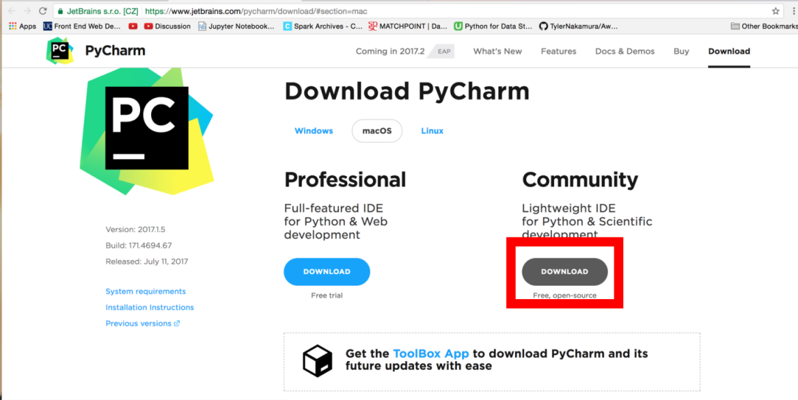

*Figure no 4.4 open the pycharm website*

**Step 2:** Download the 32 bit are 64 bit from the official website as shown below [www.pycharm.com](http://www.pycharm.com).

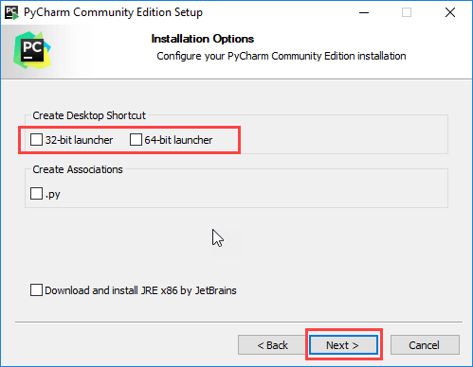

*Figure No 4.5 Select the Operation bit System*

**Step 3:** Now, This defines the environment variables. When you run the executable file, you can observe the following window on your screen. Click Next.

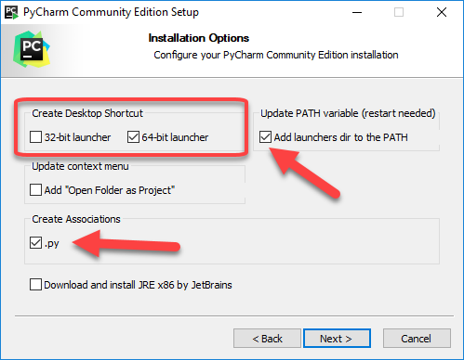

*Figure No 4.6 Setup Wizard of Editor*

**Step 4** : Now, choose a destination location to install Sublime Text3 and click Next.

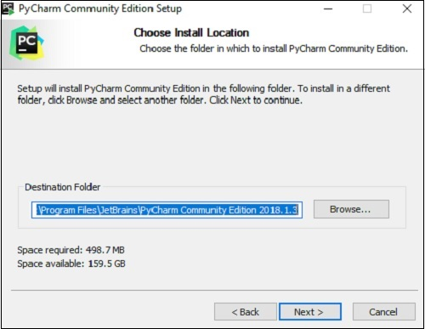

*Figure No 4.7 Select the Path Location*

**Step 5:** Verify the destination folder and click Install

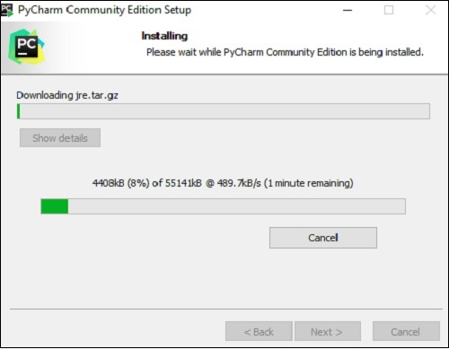

*Figure No 4.8 Click the Install button*

**Step 6:** Now, click next to complete the installation.

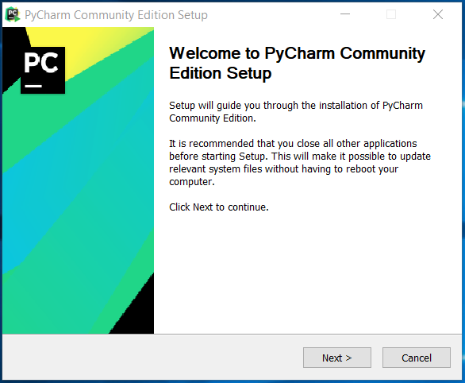

*Figure No 4.9 pycharm community setup*

**Step 7:** Upon a successful installation, you’re editor will appear as shown below

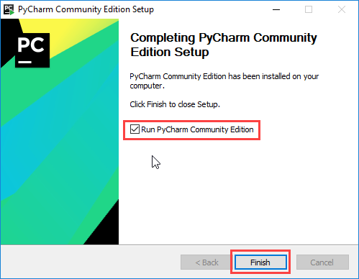

*Figure No 4.10 Ready to code*

**4.3.2 My Sql**

**Step 1**: Download Mysql Installer using mysql

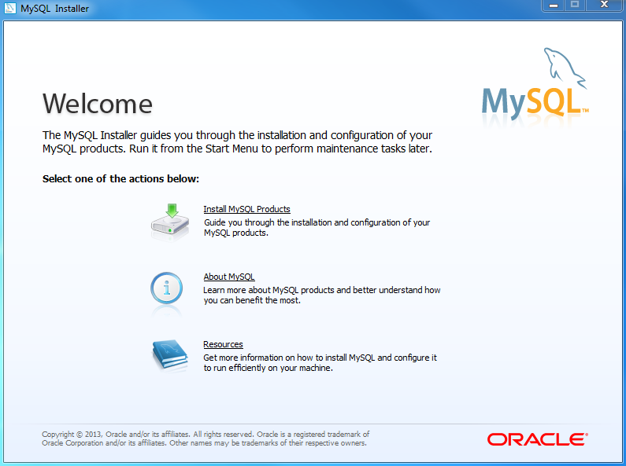

*Figure 4.11 Select Language*

**Step 2:** Click on the agreement and license and give next .

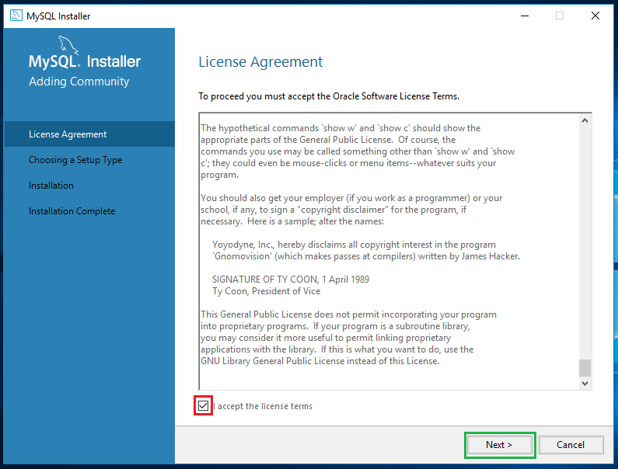

*Figure 4.12 Select License terms*

**Step 3:** Select your Installation Packages

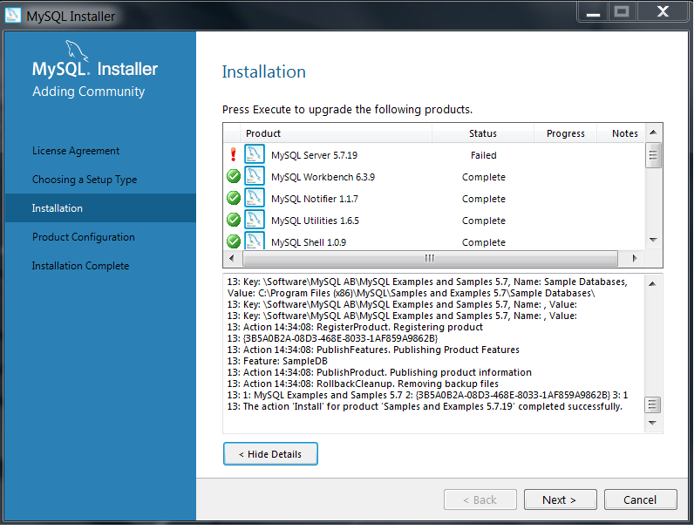

*Figure 4.13 Select Installation Packages*

**Step 4**: Specify File location and Setup type .

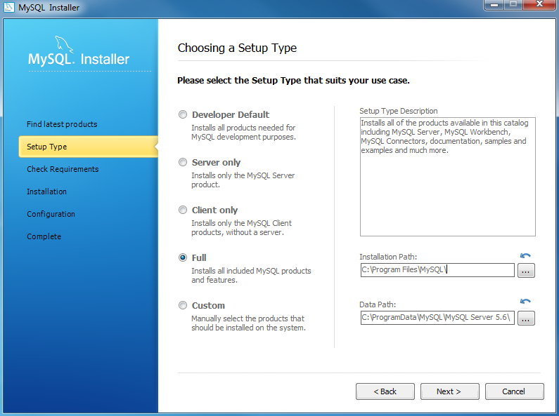

*Figure 4.14 Select Location for Download*

**Step 5:** Specify File Installation Proress .

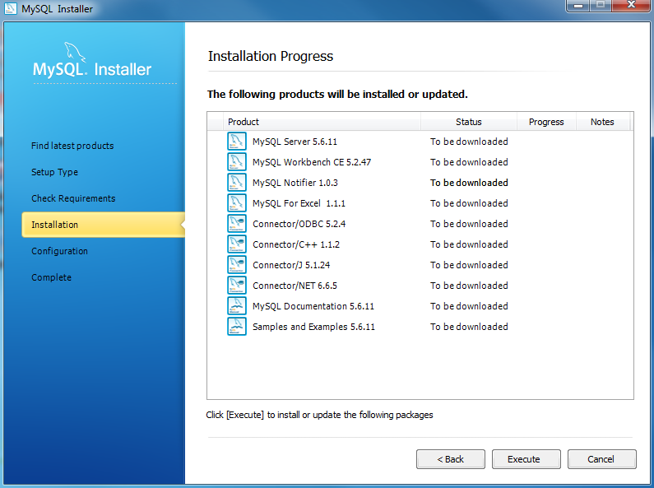

*Figure 4.15 sql packages*

**Step :6:** Specify configuration and Sql passowrd

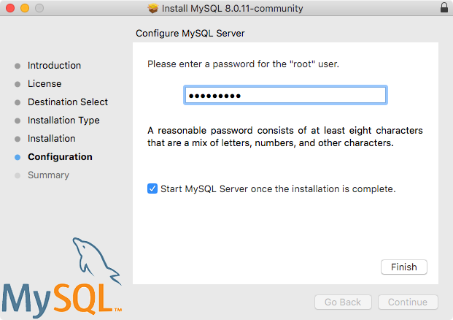

*Figure 4.16 Select passcode for access*

**4.4 User Documentation**

User documentation needs to be consistent, simple and have a thorough index. It enables a user to understand the user interface better. It enables user to understand the Graphical User Interface (GUI) better. In this project, there are various options that would be carried out by various people. The proper manual has to be given in order to have feasible access with this system. The user is the most important subtasks of the developer. For this purpose user manuals are prepared and handled over to operate the developed system.

Thus the users are trained to operate the developed system. Both hardware and software securities are made to run the developed system successfully in future. The users are trained to use the newly developed functions. User manuals describing the procedures for using the functions listed on menu are circulated to all users. It provides a document to make the end user clear in working of the software.

**4.5 Conclusion**

The application was effectively tested under different strategies. Each functionality and sub-assembly were tested completely. Each and every test result was maintained in order to keep track of the whole testing phase. Various errors were detected and rectified for each strategy before moving on to the next one. This the system was tested completely and ensured that it meet the requirements and the user’s expectations.

**CHAPTER 5**

**CONCLUSION**

**5.0 Introduction**

This chapter deals with the evaluation of the entire application in various views and then the future enhancement has to be taken into consideration. Finally, the chapter discusses in details about the technical skill that has been learned while developing the system.

**5.1 Evaluation**

Evaluation requires that the developers discard preconceived notions of the correctness of the software just developed and overcome a conflict of interest that occurs when errors are uncovered. If evaluation is encountered successfully, it uncovers errors in the software. Evaluation cannot show the absence of defect; it can only show that the software defects are present. Evaluation helps in determining the value and effectiveness of the system. Assessment and validation tools provide data for evaluation. Assessment is the measurement of the practical results of the training in the work environment; while validation determines if the objective of training goal were met

**5.1.1 Evaluation checklist The project is evaluated in two views.**

They are: Administrator view

User view

**5.1.1.1 Administrator view**

The administrator is the one who controls the web application entirely. Since the administrator controls all operation, the application, must be evaluated whether it is flexible for the administrator while adding new menu items and inventory items, approve the details and user profiles, delete unwanted and obscene details.

**5.1.1.2 User view**

It mainly deals with the verification of user satisfaction to meet the requirements. If the user is very comfortable with the application that leads him/her to share to his/her friends. The ease of use and responsive GUI, it can make the application simple and clear. Here are some evaluation checks that has been done which are linked to the objectives.

**Let’s check their point of view.**

|  |  |  |  |
| --- | --- | --- | --- |
| **EVALUATION CHECKLIST** | **YES** | **NO** | **N/A** |
| Is there a consistent design scheme that facilitates or ease he Data flow in case of any upload failure? | ✔ |  |  |
| Is there a visual representation of the business logic for better understanding? | ✔ |  |  |
| Does the system operate even when interrupted by any Network or logical error? | ✔ |  |  |
| Does the exit () closes the system abruptly without the changes being saved? |  | ✔ |  |

*Table No 6.1 Evaluation checklist*

**5.2 Future enhancements**

The future enhancements of Application might be migrating the complete project to another technology like React or it may take different concepts as per customer’s requirement. The major enhance that will made in future are Integration with demand option.

• Automation in sending important mails and information

• Adding more functionality for user management phase.

• Adding live Updates and Schemes.

• Data Records can be encrypted.

**5.2.1 System Development**

The most important fact of the system development is that is must be flexible enough for future modifications. The system has been designed and developed in such a way that it would be very easily upgraded for future requirements and flexible for future development. The project can be enhanced in a more efficient way so as to meet future development.

**5.3 Technical skills learned**

It has been a great pleasure to work on this exciting and challenging project. This project proved good as it provided practical knowledge of not only programming but also the knowledge of the best technologies which is being widely used nowadays. This project has helped to learn the following skills,

• I have learned the concepts of Python.

• I have learned basic concepts of mysql.

• I have experienced working in a real time project which helped me get exposed to

• different factors that play a main role in IT sector. I have also learnt how to interact with senior employees through reports which is

• a key source of communication within a working environment.

• I have learned how to access sql with Blockchain Technology.

**5.4 Conclusion**

This project has achieved the requirements and objectives that have been identified during analysis phase. Web Application for banking has helped to bring out solutions for several issues faced. Modifications after successful analysis can be incorporated into the system. The system has been well developed and future enhancements are also explained, so that it could be used to make any of the future modification; this making the application more scalable and flexible.

**BIBLIOGRAPHY**

**Book references**

1.Books of banking - by Alex Banksand Eve Porcello | 16 May 2017 . by Richard Banks

2. Baker, Mitchell (14 May 2014). "DRM and the Challenge of Serving Users". Mozilla. Retrieved 20 May 2014.

3. Cederholm, Dan; Ethan Marcotte (2009). Handcrafted CSS: More Bulletproof Web Design. New Riders. p. 114. ISBN 978-0-321-64338-4. Archived from the original on 20 December 2012. Retrieved 19 June 2010.

4. Berkus, Josh (July 6, 2007). "PostgreSQL publishes first real benchmark". Archived from the original on July 12, 2007. Retrieved July 10, 2007.

**Web references**

1. https://www.youtube.com/watch?v=8kflIVBb1w0 – Setting remainders

2. https://www.w3schools.com/css/css3_gradients.asp - Fixing gradients to the page

3. https://www.postgresql.org/docs/7.3/jdbc-binary-data.html - Data Storage

4. https://www.geeksforgeeks.org/html5-footer-tag/ - Adding footer with icons.

5. <https://youtu.be/hGUuFs4CZVg> - Banking using bloackchain

**APPENDIX**

**SCREENSHOTS**

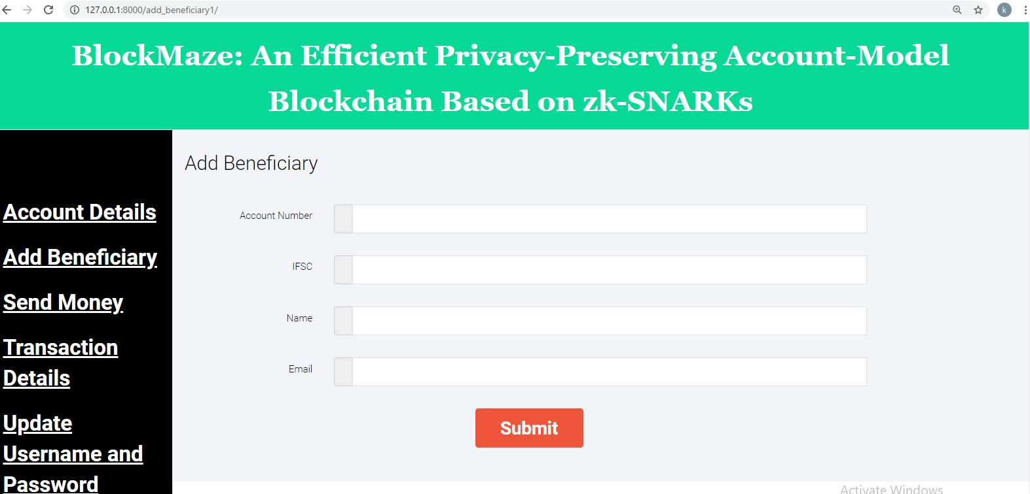

**Add Beneficiary** 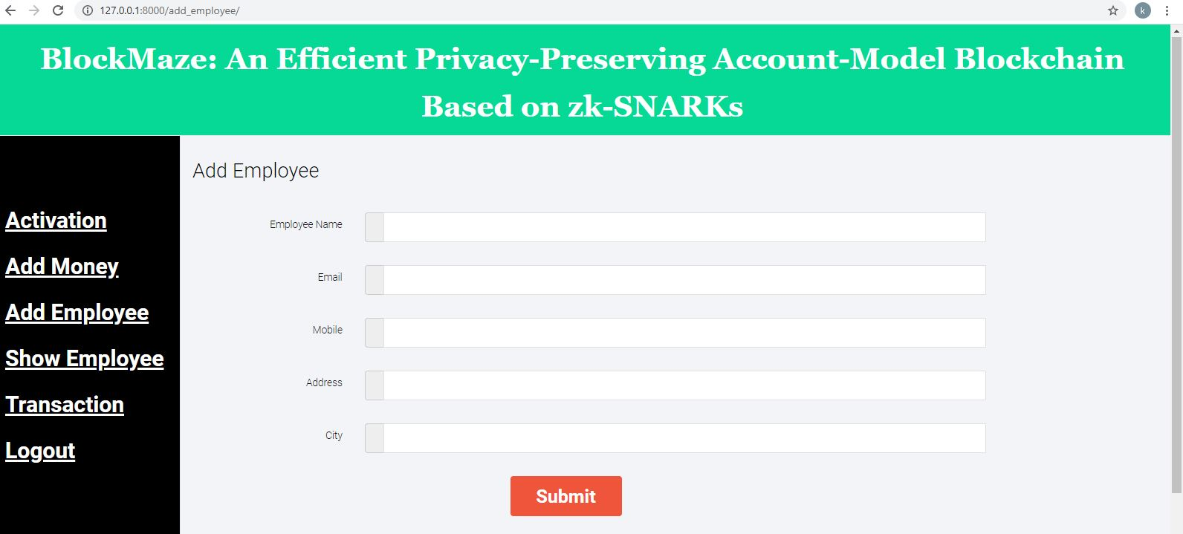

**Add Employee**

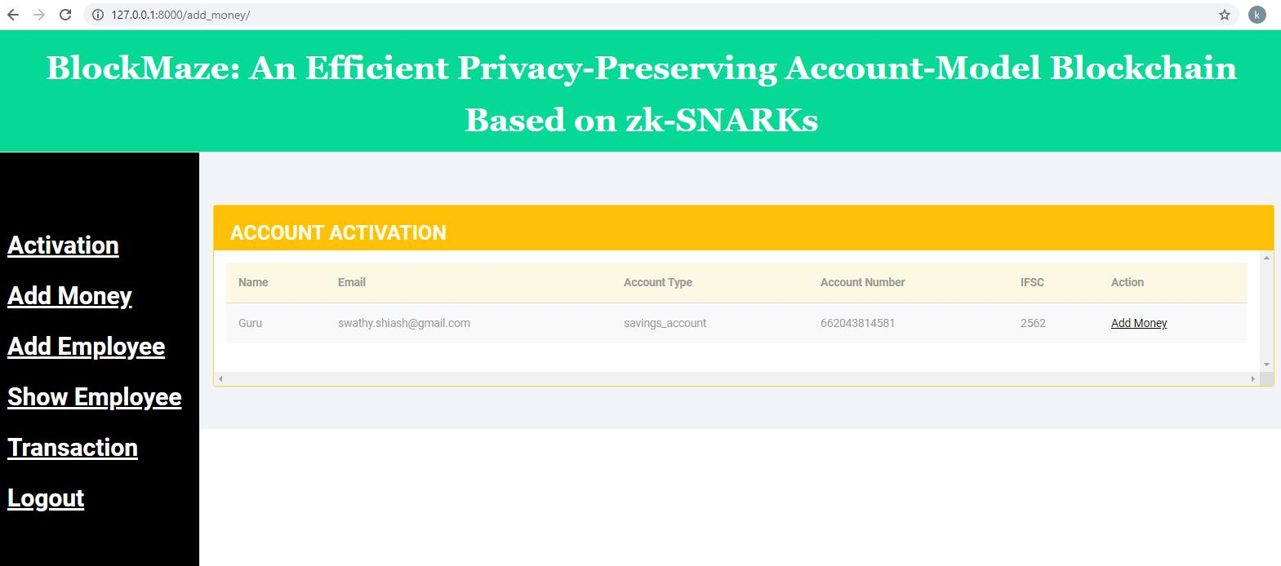

**Account Activation**

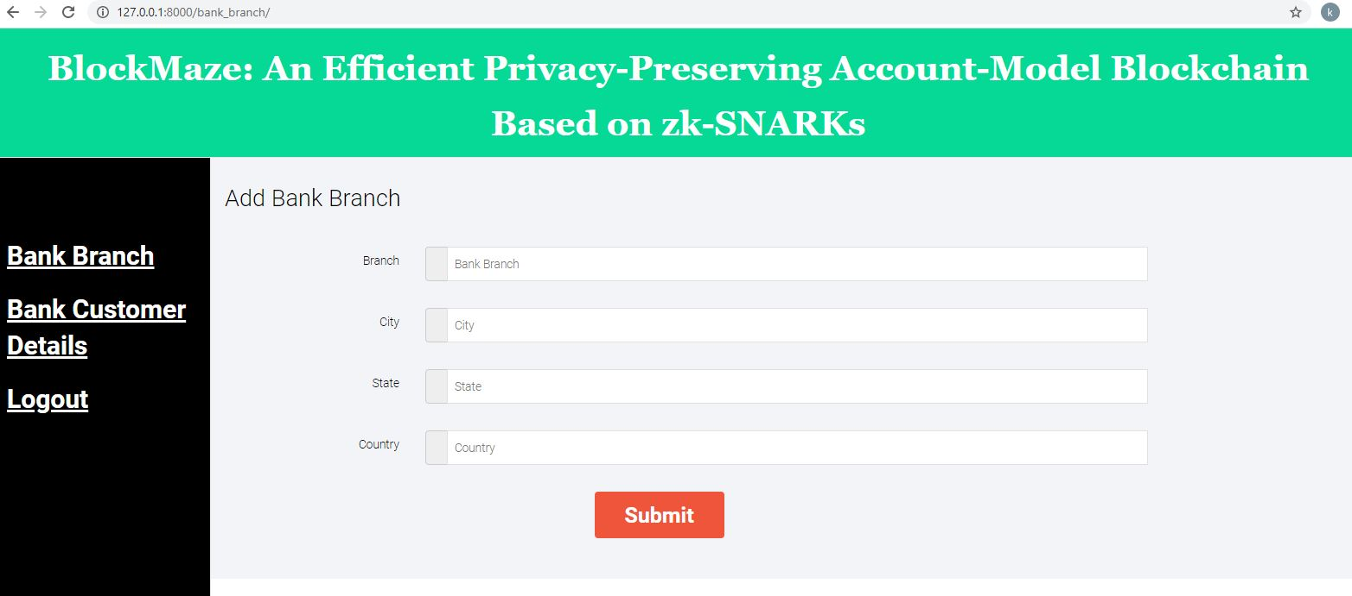

**Add Bank Branch**

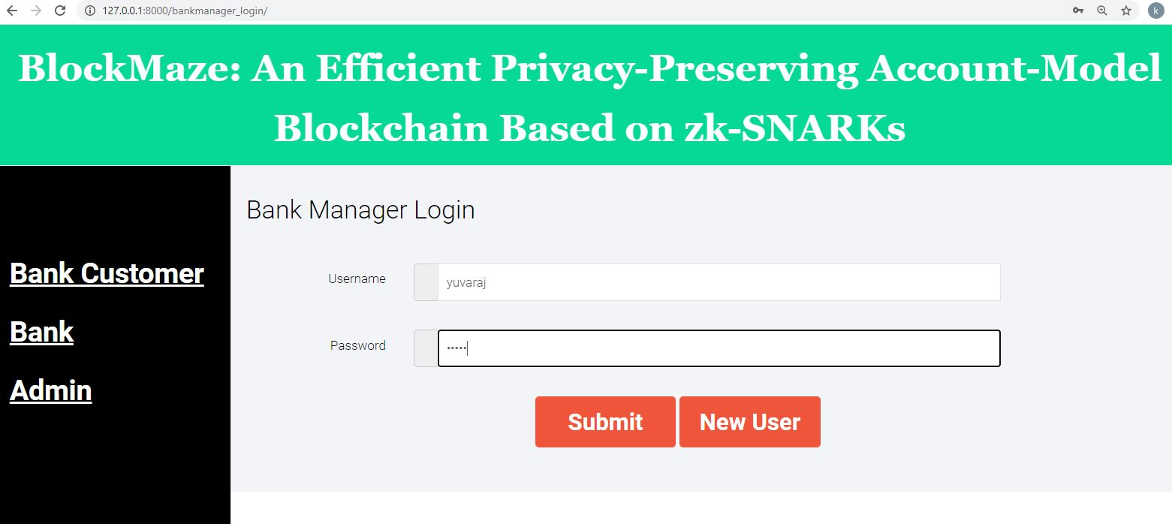

**Admin Login** 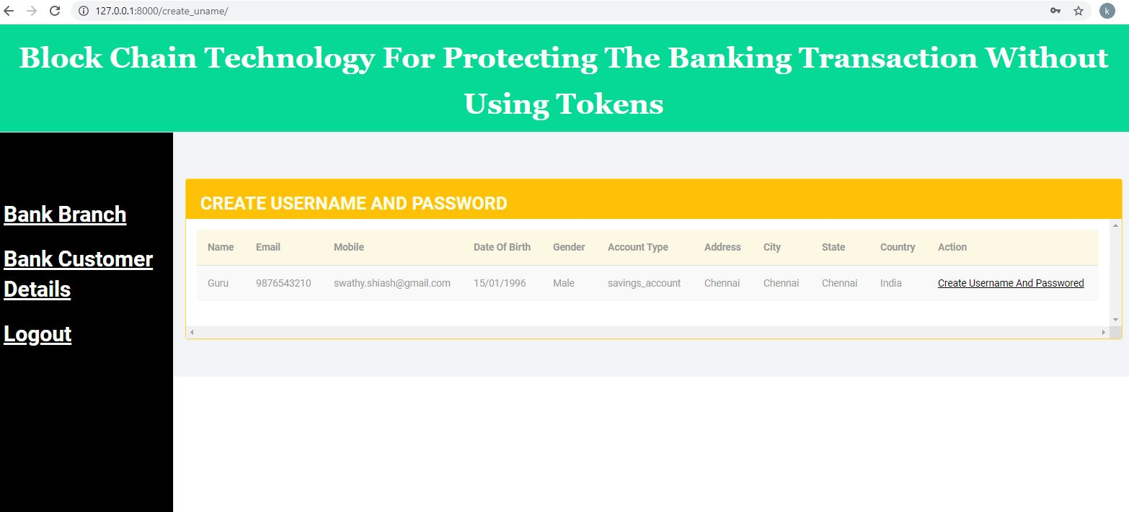

**Create Username and Password**

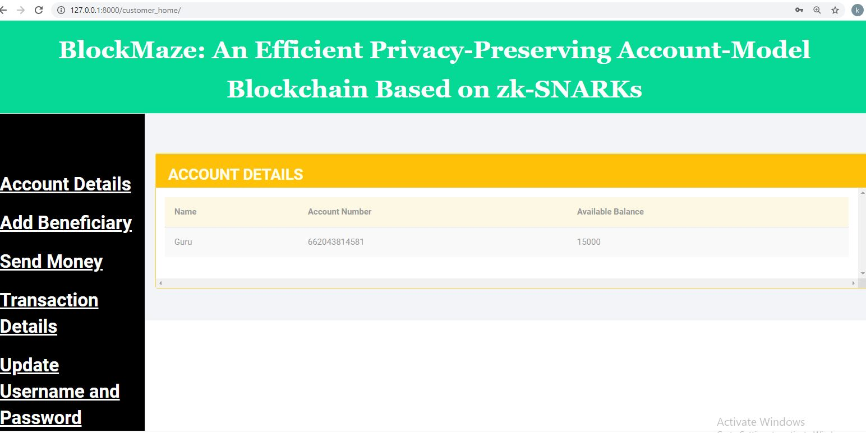

**Account Details**  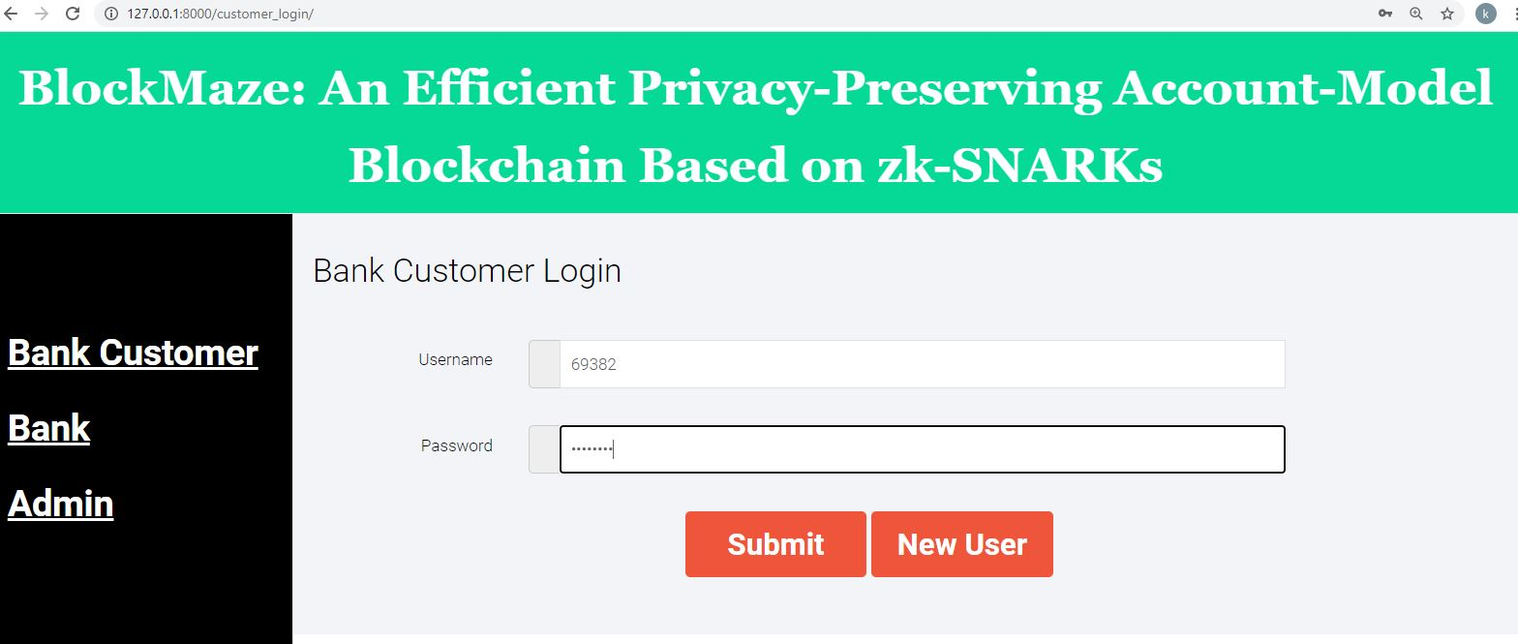

**Bank Customer Login**

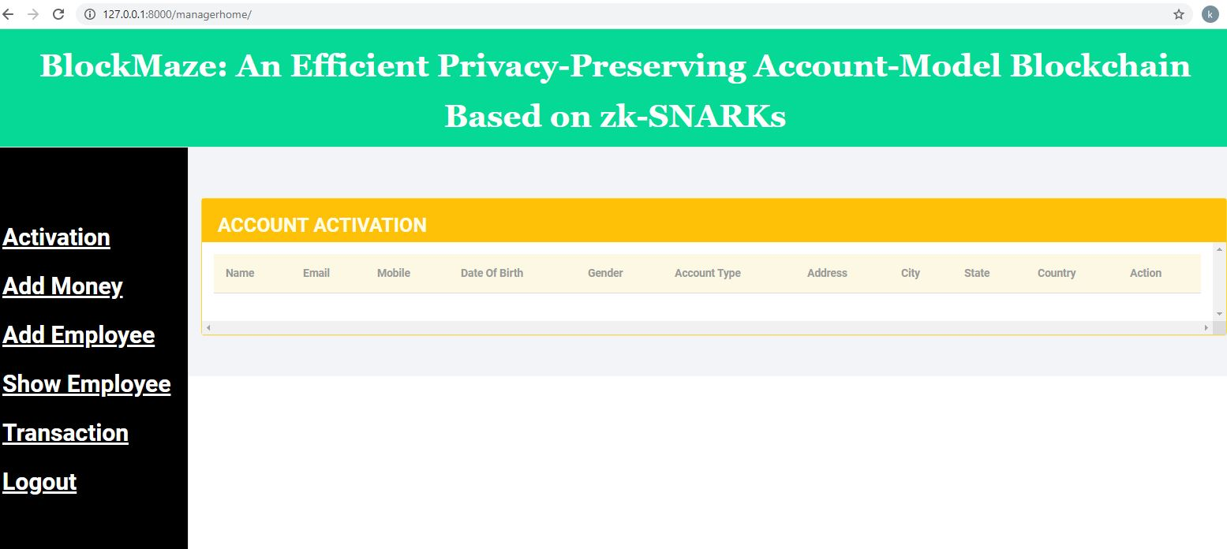

**Account Activation**

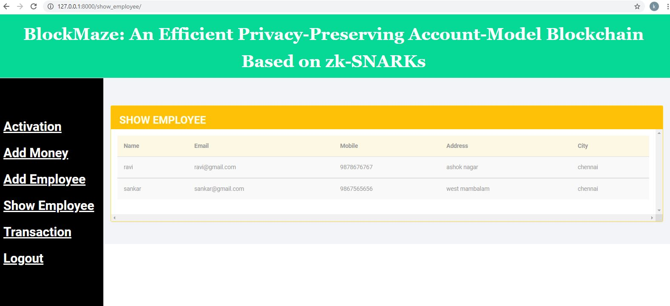

**Show Employee**

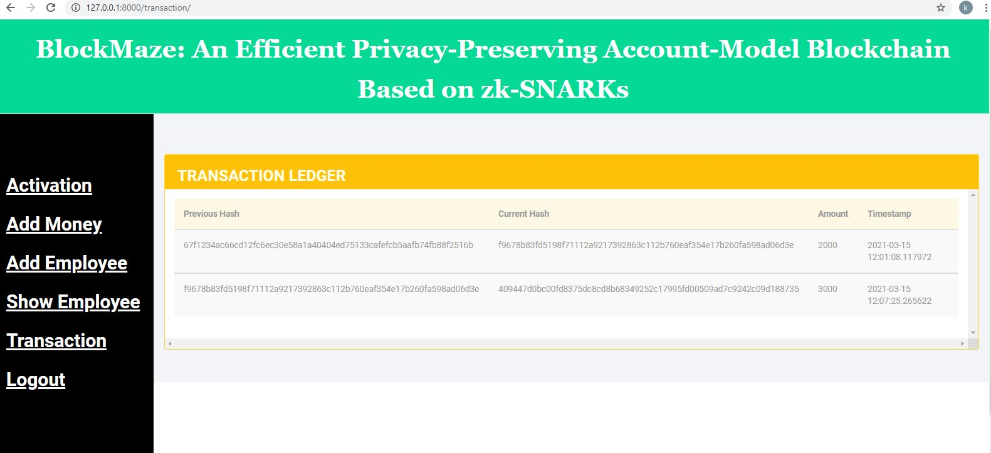

**Transaction Ledger**

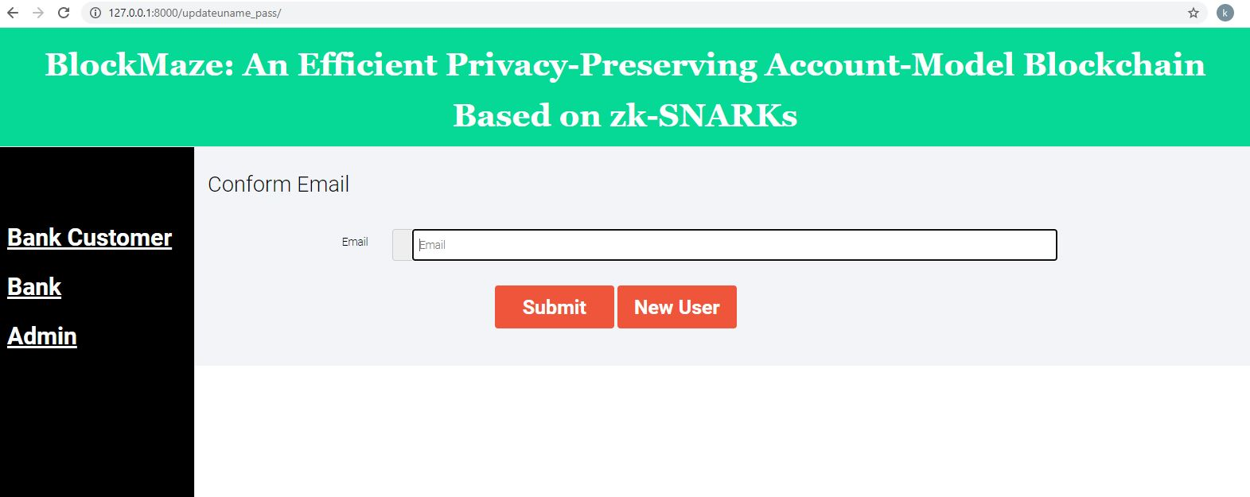

**Confirm Email**

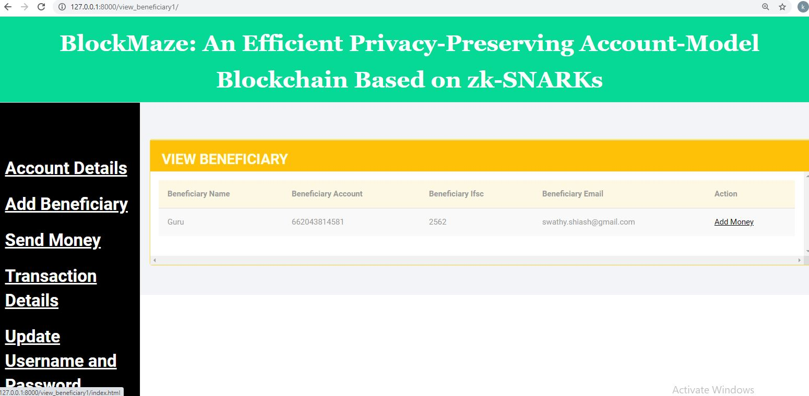

**View Beneficiary**

**WEEKLY REPORT**

**Department No : 18 – PCA - 025**

**Student Name : S.GOPINATH**

**Company Name : Candid techno solution**

**Title : Dynamic concealment in recital visual blockchain**

**Weekly Report :1st ( 4-1-2021 to 10-1-2021 )**

|  |  |  |
| --- | --- | --- |
| **S.No** | **DATE** | **ACTIVITY** |
| **1** | **4-1-2021** | **Zeroth review in college** |
| **2** | **5-1-2021** | **Self Intro in meeting with company** |
| **3** | **6-1-2021** | **Project title decision meeting in company** |
| **4** | **7-1-2021** | **SRM Campus Preparation** |
| **5** | **8-1-2021** | **SRM Campus Examination** |
| **6** | **9-1-2021** | **Pycharm Tools basic Learning** |
| **7** | **10-1-2021** | **Company Holiday** |

**Project Guide Project Company Guide**

**WEEKLY REPORT**

**Department No : 18 – PCA - 025**

**Student Name : S.GOPINATH**

**Company Name : Candid techno solution**

**Title : Dynamic concealment in recital visual blockchain**

**Weekly Report :2nd ( 11-1-2021 to 17-1-2021 )**

|  |  |  |
| --- | --- | --- |
| **S.No** | **DATE** | **ACTIVITY** |
| **1** | **11-1-2021** | **Project details studying** |
| **2** | **12-1-2021** | **SDLC phases studying** |
| **3** | **13-1-2021** | **SDLC 7 Stages process Undergoing** |
| **4** | **14-1-2021** | **Pongal Hoilday** |
| **5** | **15-1-2021** | **Pongal Hoilday** |
| **6** | **16-1-2021** | **Pongal Hoilday** |
| **7** | **17-1-2021** | **Company Holiday** |

**Project Guide Project Company Guide**

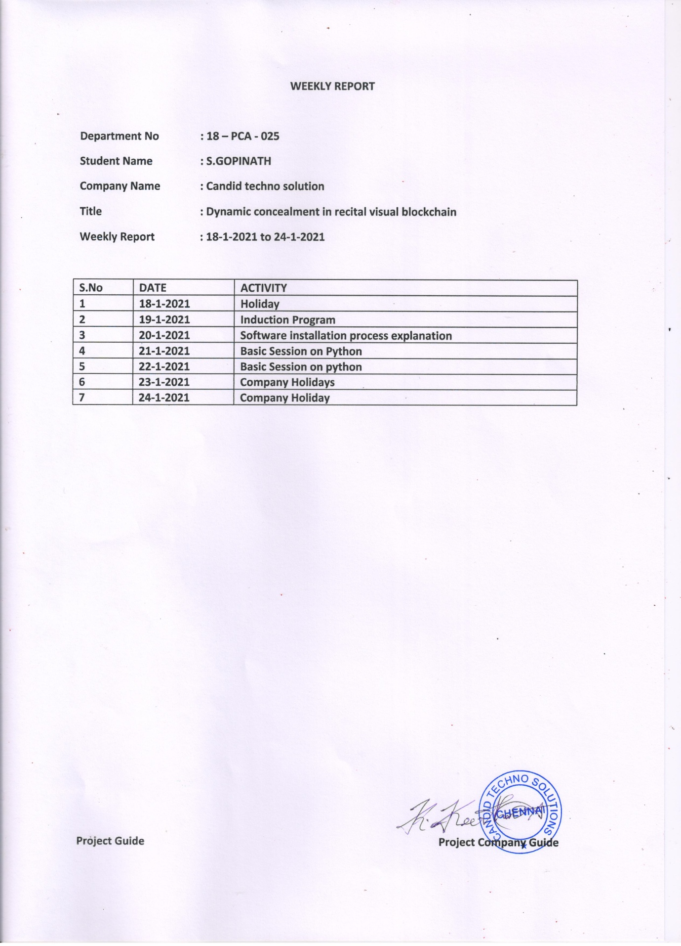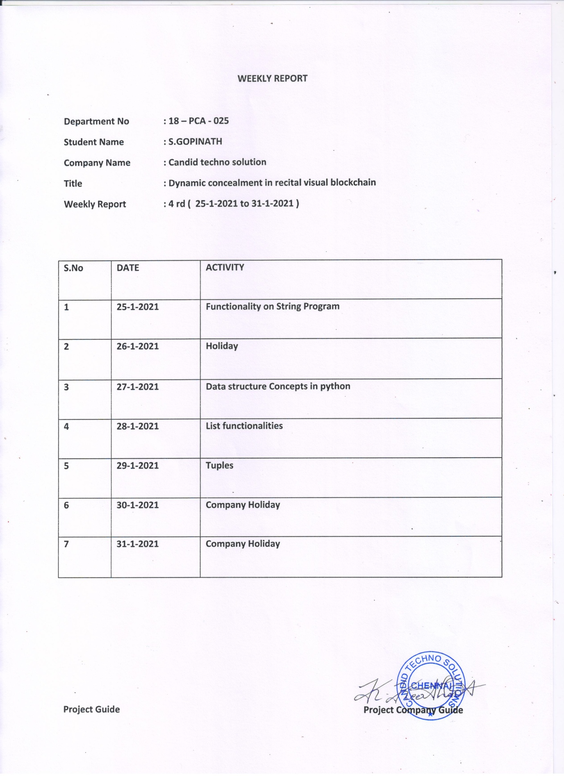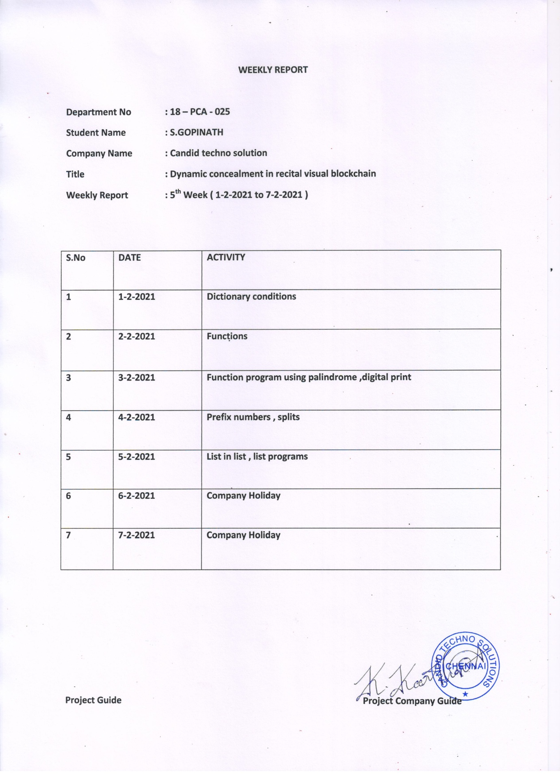

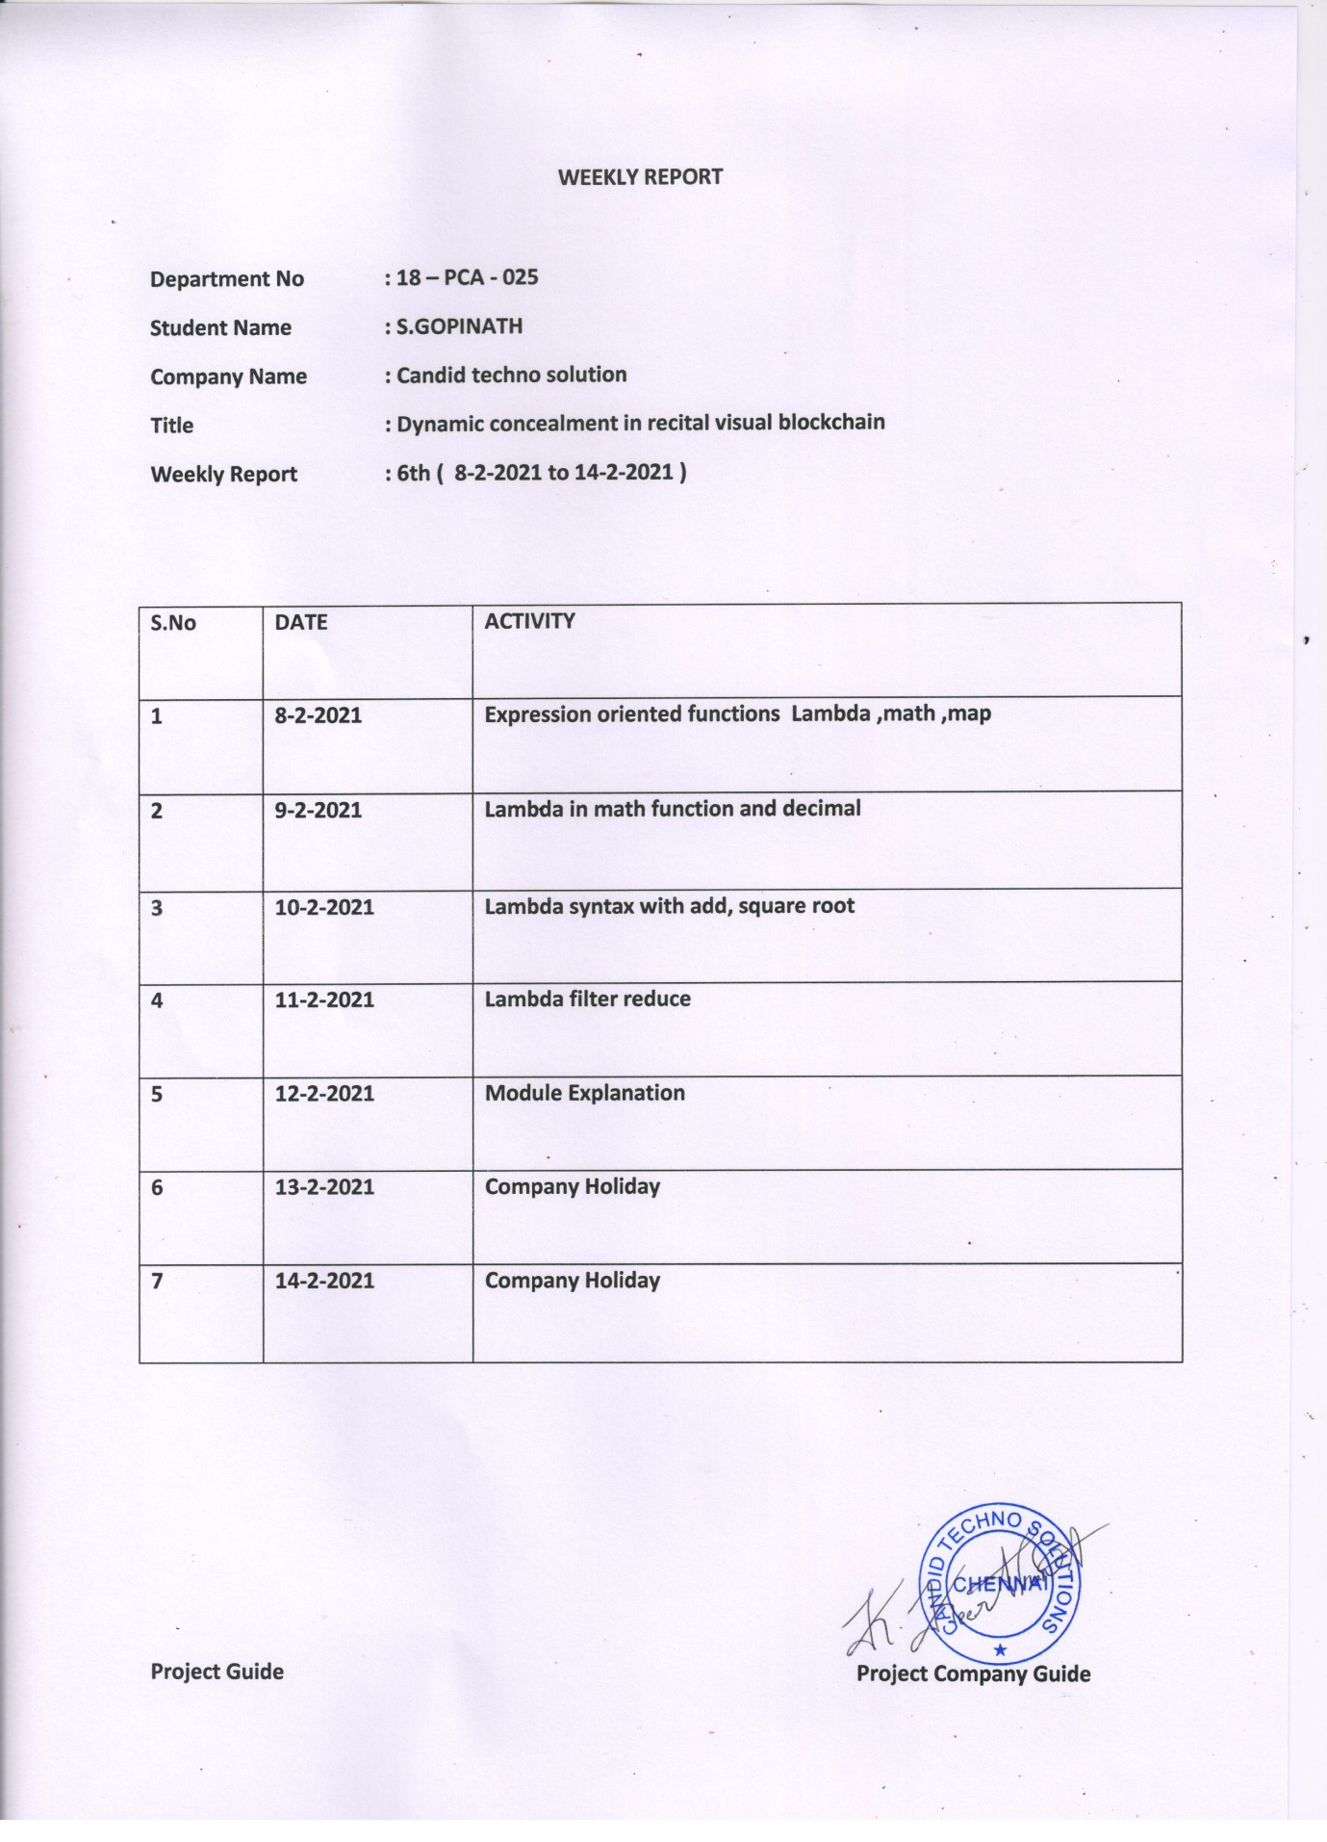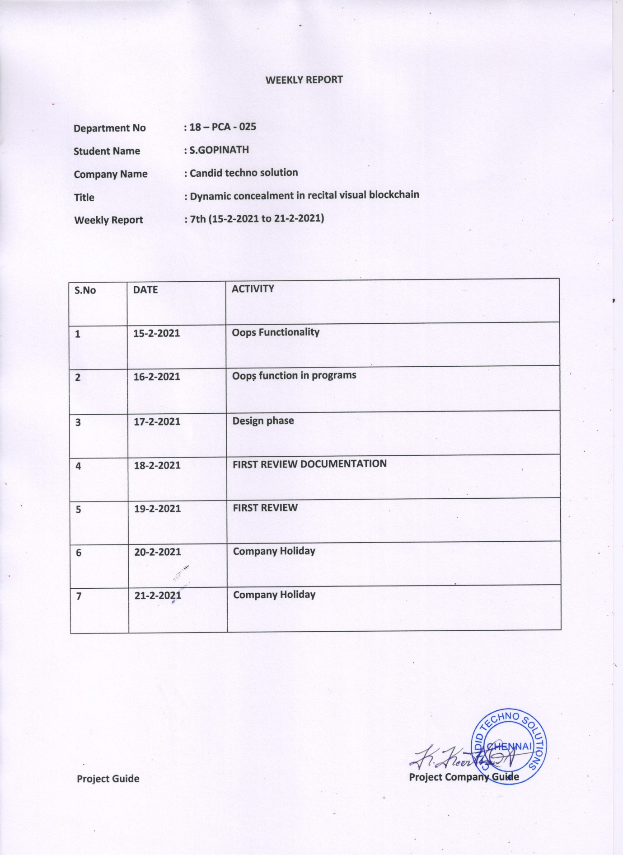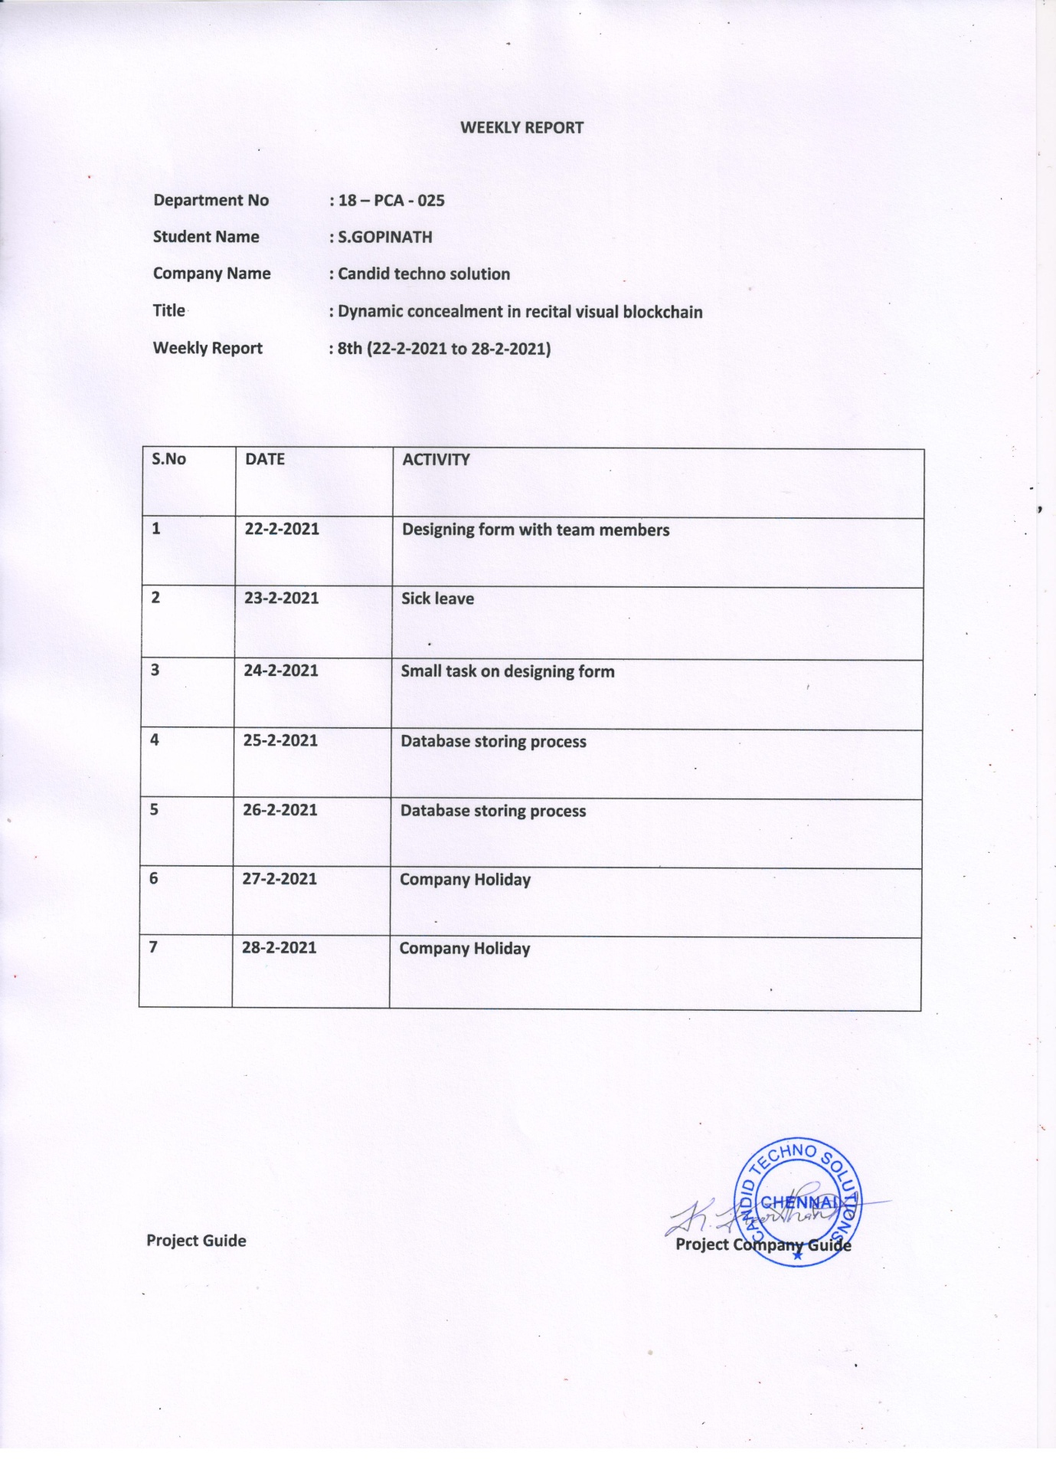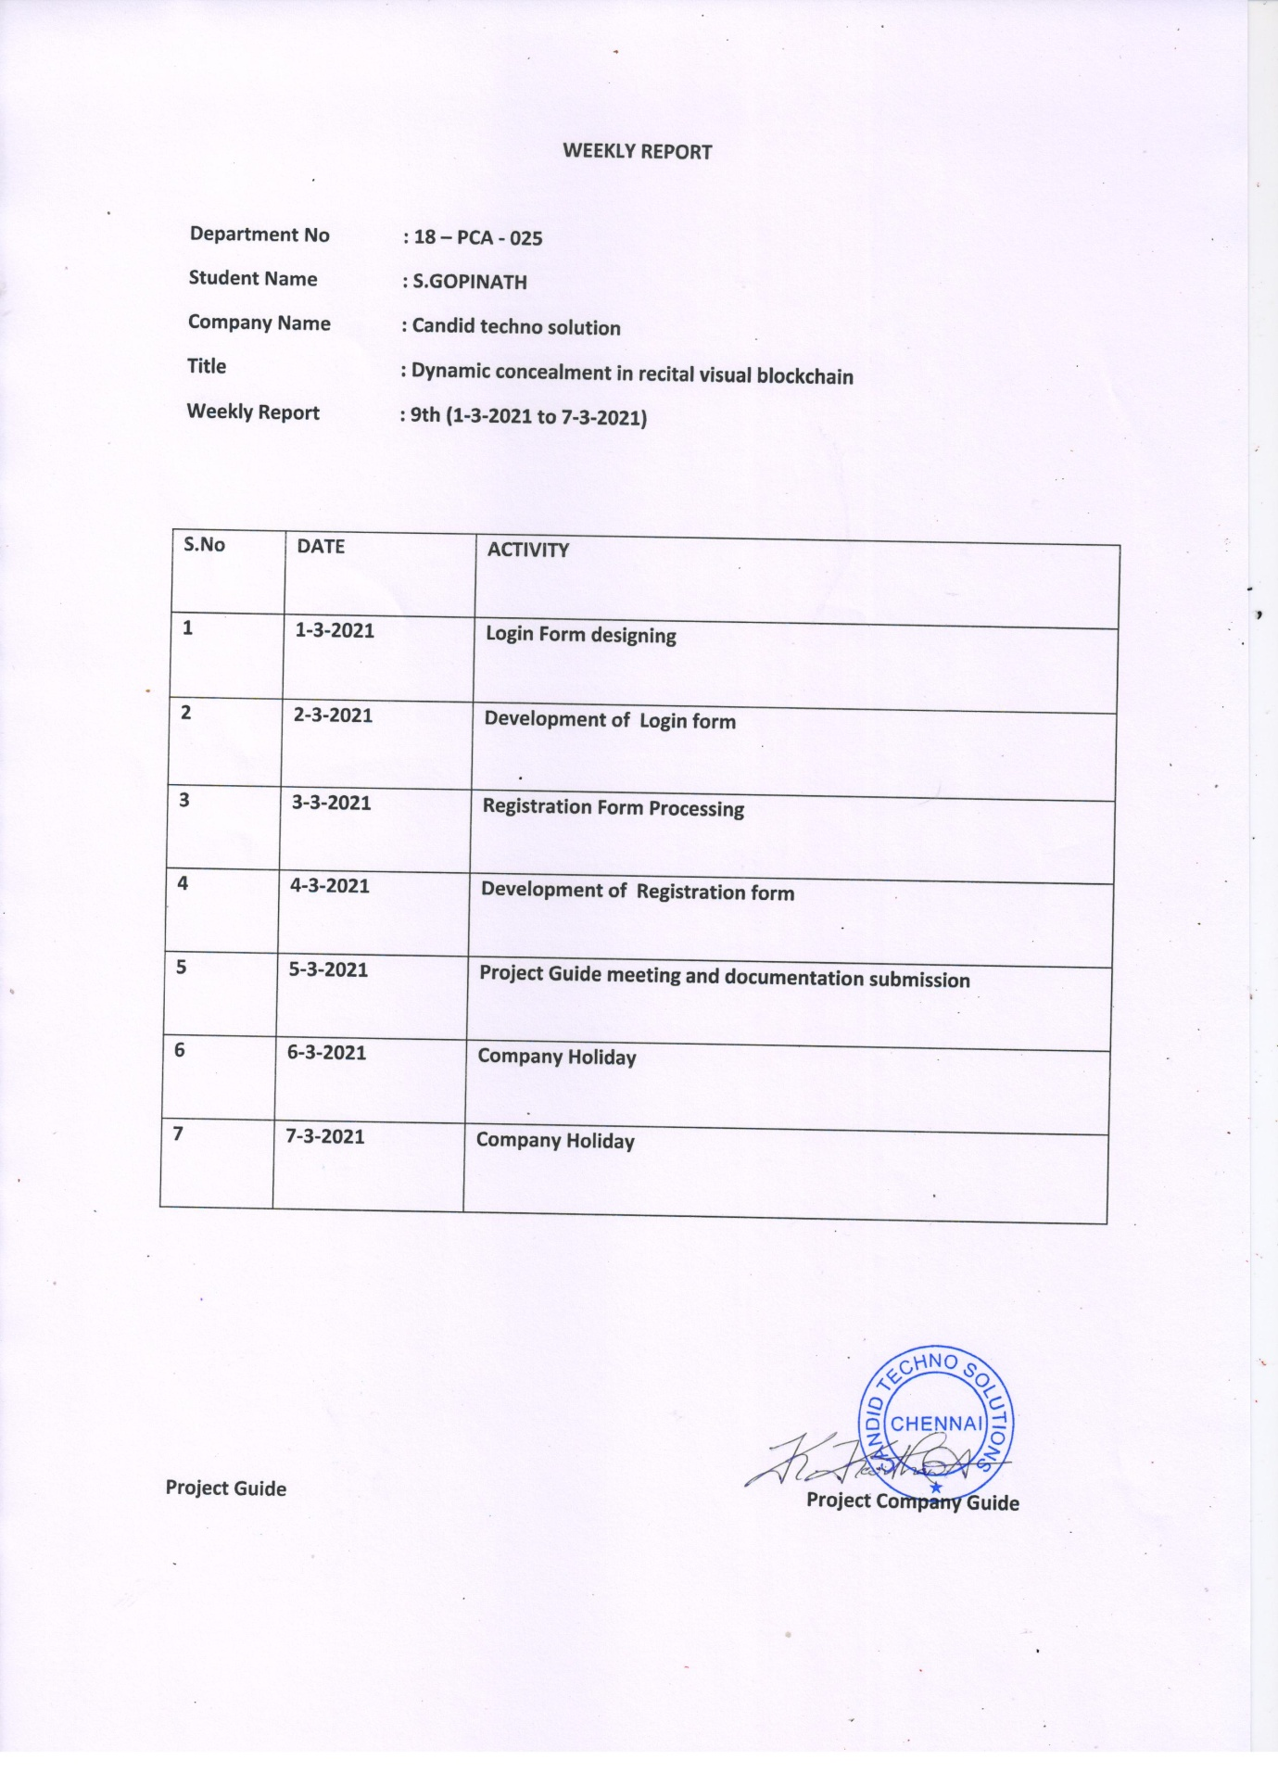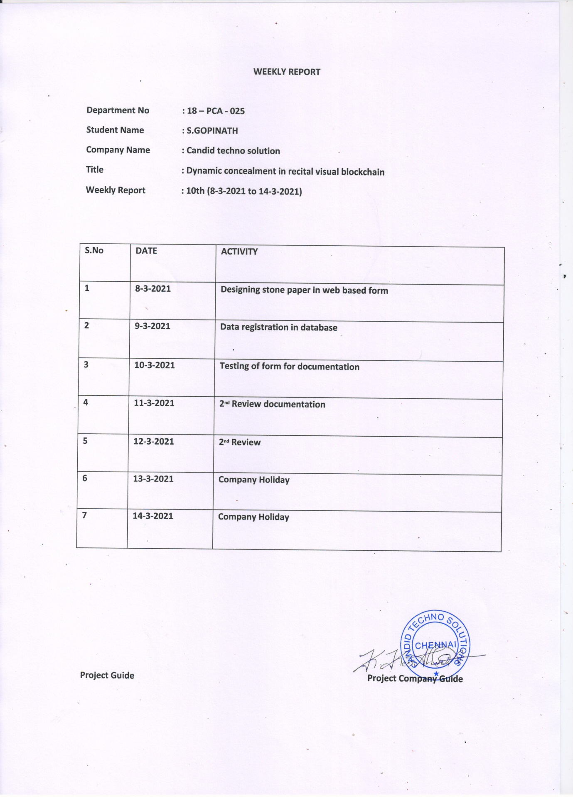

**WEEKLY REPORT**

**Department No : 18 – PCA - 025**

**Student Name : S.GOPINATH**

**Company Name : Candid techno solution**

**Title : Dynamic concealment in recital visual blockchain**

**Weekly Report :11th (15-3-2021 to 21-3-2021)**

|  |  |  |
| --- | --- | --- |
| **S.No** | **DATE** | **ACTIVITY** |
| **1** | **15-3-2021** | **Meeting regards project and splitting of works** |
| **2** | **16-3-2021** | **Transaction form designing task** |
| **3** | **17-3-2021** | **Processing in backend database** |
| **4** | **18-3-2021** | **Retrieving data’s from backend** |
| **5** | **19-3-2021** | **Functionality of the module** |
| **6** | **20-3-2021** | **Company Holiday** |
| **7** | **21-3-2021** | **Company Holiday** |

**Project Guide Project Company Guide**

**WEEKLY REPORT**

**Department No : 18 – PCA - 025**

**Student Name : S.GOPINATH**

**Company Name : Candid techno solution**

**Title : Dynamic concealment in recital visual blockchain**

**Weekly Report :12th (22-3-2021 to 28-3-2021)**

|  |  |  |
| --- | --- | --- |
| **S.No** | **DATE** | **ACTIVITY** |
| **1** | **22-3-2021** | **Add Beneficiary Development** |
| **2** | **23-3-2021** | **Add Beneficiary Development** |
| **3** | **24-3-2021** | **Add Employee Designing** |
| **4** | **25-3-2021** | **Add Employee Designing and Developnment** |
| **5** | **26-3-2021** | **Add Money Form Deelopment** |
| **6** | **27-3-2021** | **Company Holiday** |
| **7** | **28-3-2021** | **Company Holiday** |

**Project Guide Project Company Guide**

**WEEKLY REPORT**

**Department No : 18 – PCA - 025**

**Student Name : S.GOPINATH**

**Company Name : Candid techno solution**

**Title : Dynamic concealment in recital visual blockchain**

**Weekly Report :13th (29-3-2021 to 4-4-2021)**

|  |  |  |
| --- | --- | --- |
| **S.No** | **DATE** | **ACTIVITY** |
| **1** | **29-3-2021** | **Add Money From Designing** |
| **2** | **30-3-2021** | **Add Money From Designing** |
| **3** | **31-3-2021** | **Backend Database Storing** |
| **4** | **1-4-2021** | **Documentation verification and meeting HR** |
| **5** | **2-4-2021** | **Internship Completion** |
| **6** | **3-4-2021** | **Company Holiday** |
| **7** | **4-4-2021** | **Company Holiday** |

**Project Guide Project Company Guide**

**MONTHLY REPORT**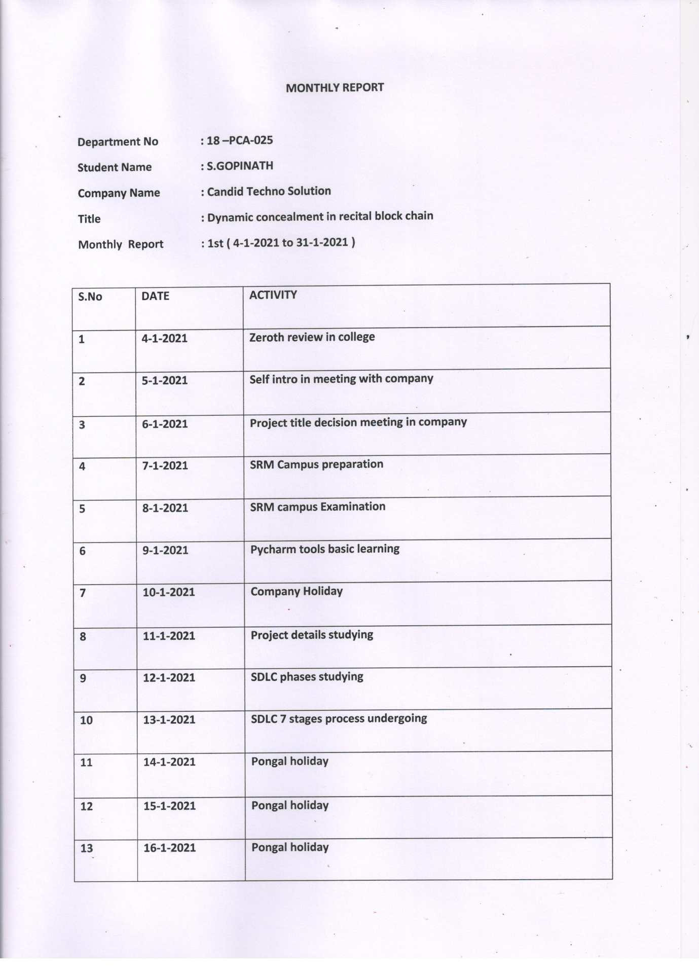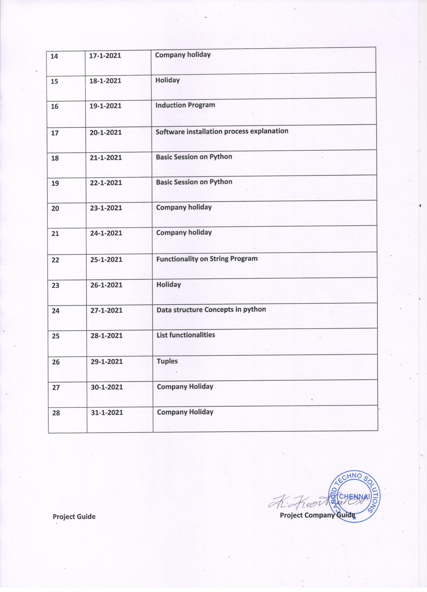

**MONTHLY REPORT 2**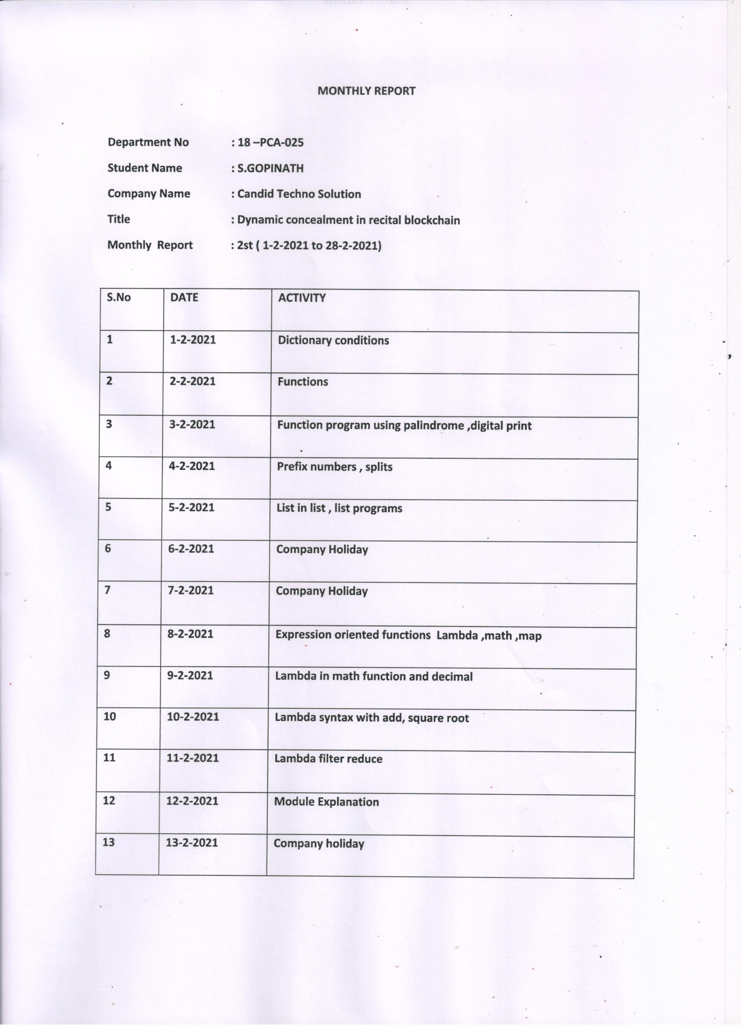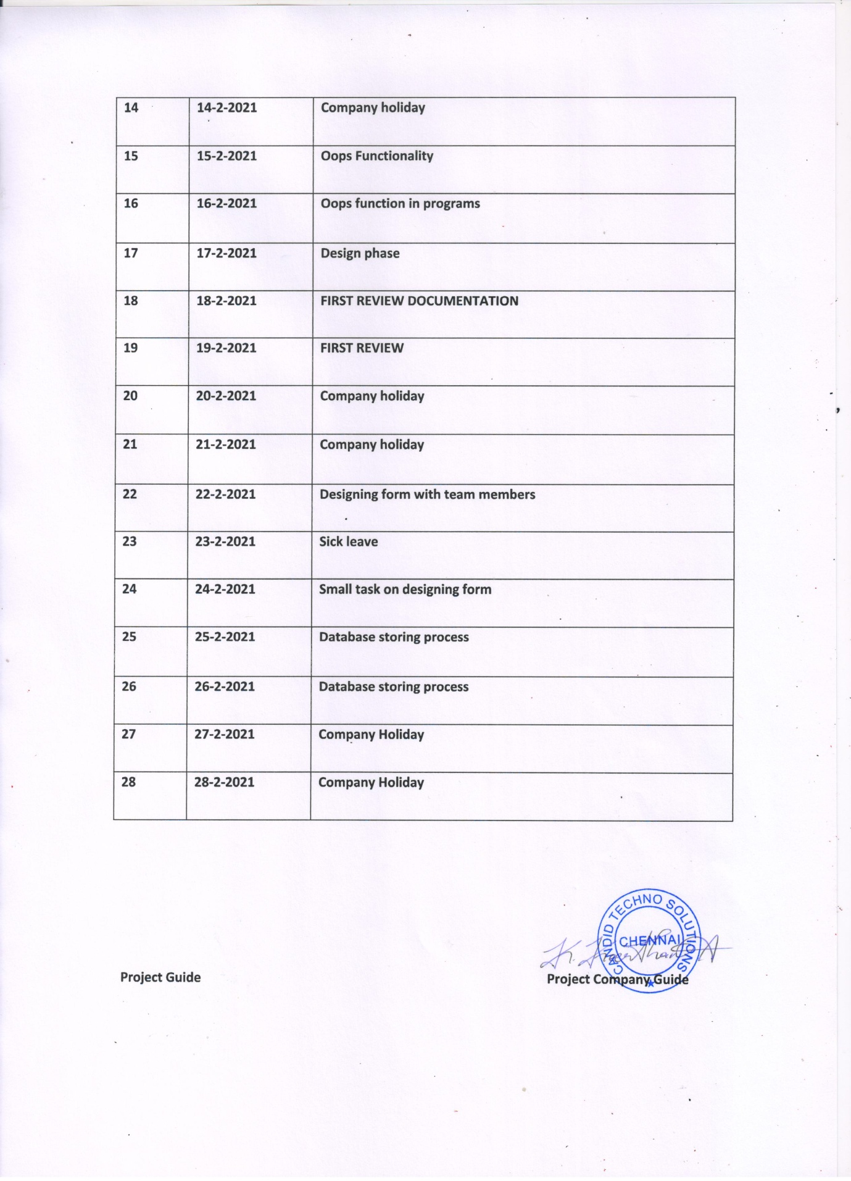

**MONTHLY REPORT 3**

**MONTHLY REPORT**

**Department No : 18 –PCA-025**

**Student Name :S.GOPINATH**

**Company Name : Candid Techno Solution**

**Title : Dynamic concealment in recital blockchain**

**Monthly Report : 3rd( 1-3-2021 to 4-4-2021)**

|  |  |  |
| --- | --- | --- |
| **S.No** | **DATE** | **ACTIVITY** |
| **1** | **1-3-2021** | **Login form Designing** |
| **2** | **2-3-2021** | **Development of login form** |
| **3** | **3-3-2021** | **Registration Form Processing** |
| **4** | **4-3-2021** | **Development of Registration form** |
| **5** | **5-3-2021** | **Project Guide meeting and Documentation Submission** |
| **6** | **6-3-2021** | **Company Holiday** |
| **7** | **7-3-2021** | **Company Holiday** |
| **8** | **8-3-2021** | **Designing stone page In web bases form** |
| **9** | **9-3-2021** | **Data Registration in database** |
| **10** | **10-3-2021** | **Testing of form for documentation** |
| **11** | **11-3-2021** | **2nd review Documentation** |
| **12** | **12-3-2021** | **2nd Review** |
| **13** | **13-3-2021** | **Company holiday** |
| **14** | **14-3-2021** | **Company holiday** |
| **15** | **15-3-2021** | **Meeting regards Project and splitting of works** |
| **16** | **16-3-2021** | **Transaction form designing** |
| **17** | **17-3-2021** | **Processing in backend database** |
| **18** | **18-3-2021** | **Retrieving data’s from backend** |
| **19** | **19-3-2021** | **Functionality of the module** |
| **20** | **20-3-2021** | **Company holiday** |
| **21** | **21-3-2021** | **Company holiday** |
| **22** | **22-3-2021** | **Add Beneficiary Development** |
| **23** | **23-3-2021** | **Add Beneficiary Development** |
| **24** | **24-3-2021** | **Add Employee Designing** |
| **25** | **25-3-2021** | **Add Employee Designing and Developnment** |
| **26** | **26-3-2021** | **Add Money Form Deelopment** |
| **27** | **27-3-2021** | **Company Holiday** |
| **28** | **28-3-2021** | **Company Holiday** |
| **29** | **29-3-2021** | **Add Money From Designing** |
| **30** | **30-3-2021** | **Add Money From Designing** |
| **31** | **31-3-2021** | **Backend Database Storing** |
| **32** | **1-4-2021** | **Documentation verification and meeting HR** |
| **33** | **2-4-2021** | **Internship Completion** |
| **34** | **3-4-2021** | **Company Holiday** |
| **35** | **4-4-2021** | **Company Holiday** |

**Project Guide Project Company Guide**